Properties of Water Lab Name:
Block:

Introduction:
Water is a polar covalent molecule with ionic characteristics that makes it perfect to support life processes. Organisms are made up of 40 to 95% water. Water is made up of one oxygen atom that is covalently bonded to two hydrogen atoms. Because oxygen is more electronegative than hydrogen, electrons are more attracted to the oxygen and, therefore spend more time around the oxygen than they do around hydrogen. This results in water having a slightly more negative pole on the oxygen side and slightly more positive poles on the hydrogen sides. See diagram below.
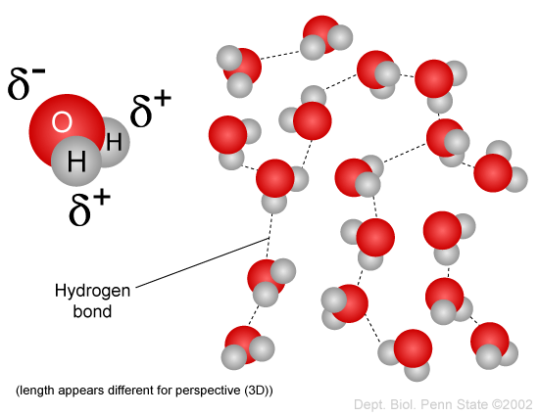
Since opposite charges attract, the positive (hydrogen) ends of one water molecule are attracted to the negative (oxygen) ends of another water molecule. This attraction will form, what are called, hydrogen bonds. Even though these hydrogen bonds are not permanent, yet they are strong. It is this strength that makes water such a unique molecule that has so many life supporting properties.

Answer the following questions:
- What property of water is described by its molecules being extremely attracted to each other and sticking to one another?

- What property of water is described by water’s surface being able to withstand force without breaking?

- What property of water is described by its molecules being attracted to other surfaces with charge?

- What property of water described when water can absorb large amounts of energy before going from liquid to a gas?

  - Using the kinetic molecular theory, describe what happens to the water molecules as they are heated and must change from a liquid to a gas? What role do hydrogen bonds (cohesion) play in this respect?

Part 1 – Cohesion
Place a coin flat on your table.
You will be adding as many droplets of water on it as possible without spilling.
BEFORE EXPERIMENT
- What is the coin you are using? ___________ How many droplets do you think you can add before it spills over? _____________?
AFTER EXPERIMENT
- How many droplets did were you able to place before it spilled over?___________
- Using your knowledge of cohesion, explain what is happening to the water molecules as you keep adding droplets.

Part 2 – Surface Tension
Do the same experiment using a different coin or making sure that your coin is completely dry before using it. However, this time stop short of 2-3 drops of water before it spills. Douse a toothpick in detergent and touch the top of the water “bubble”.
BEFORE EXPERIMENT
- Why does the coin have to be completely dry before you use it again?

- Detergent is a type of surfactant. Surfactants are molecules with one hydrophilic (water loving) end and one hydrophobic (water hating) end (figure below).
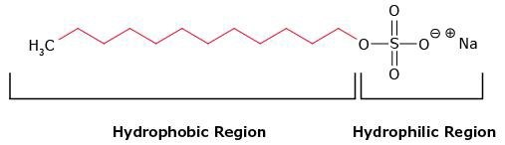
- What do you think makes the hydrophilic region attracted to water and the hydrophobic region not attracted to water?

- What do you think will happen as you touch the water bubble with the detergent?

AFTER EXPERIMENT
- What happened when detergent was added to the water “bubble”?

- Using your knowledge of surface tension and cohesion, describe what happened at the molecular level.

Part 3 – Adhesion
Put a 5-10 drops of water on wax paper and the same amount on a glass slide. Observe the difference.
BEFORE EXPERIMENT
- Do you think that there will be a difference? If so how?

AFTER EXPERIEMTN
- What was the difference between the two?

- Using your knowledge of adhesion, cohesion, surface tension and polarity, describe what you think happened at the molecular level.

Part 4 – Specific Heat Capacity
Water is known to be able to “absorb” and “store” heat. Cities like Vancouver, that are right on the ocean have much milder temperatures because the ocean reduces the extremes of temperatures both in the winter and in the summer. Whereas cities farther away from the coast, such as Abbetsford, will experience hotter summers and colder winters. Water has a high specific heat capacity. This means that lots of energy needs to be added to raise its temperature. The energy that is added will move the water molecules more quickly, but water molecules will resist changing to the gas phase.
BEFORE EXPERIMENT
- Using your knowledge of cohesion, why do you think water can “absorb” so much heat and still not evaporate?
In this experiment you will observe the difference in temperature change of tap water and salt water. In a 250mL beaker add 100mL of tap water. In another 250mL beaker add another 100mL of water, but add 2 table spoons of salt and dissolve. Place a thermometer in each beaker and place both beaker on a hot plate.
- What do you think will happen to each beaker of water?

AFTER EXPERIMENT
- What was the difference between the two beakers of water?

- Using your knowledge of cohesion and A BIT OF RESEARCH about what happens when salt dissolves in water, describe your observations at the molecular level.

Research and Reflect:
Using your learning and some research, make some connections about how each of the properties of water tested above plays a role in the survival of organisms, ecosystems and/or human societies (use examples).
______________________________________________________________________________________________________________________________________________________________________________________________________________________________________________________________________________
______________________________________________________________________________________________________________________________________________________________________________________________________________________________________________________________________________
______________________________________________________________________________________________________________________________________________________________________________________________________________________________________________________________________________
______________________________________________________________________________________________________________________________________________________________________________________________________________________________________________________________________________
______________________________________________________________________________________________________________________________________________________________________________________________________________________________________________________________________________
______________________________________________________________________________________________________________________________________________________________________________________________________________________________________________________________________________
____________________________________________________________________________________________________________________________________________________________________________________

