Bacteria – the basics Name:
Block:

- Compare and contrast prokaryotes and eukaryotes

- Identify each of the following structures on the bacterium below and describe the function of each.
Capsule
Cell membrane
Cell wall
Chromosome
Flagella
Pilus
Plasmid
Ribosomes
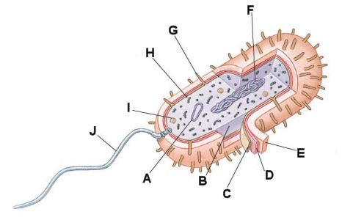

- Describe the three main groups within kingdom archaea (archaobacteria) and the characteristics that distinguish them.

- How can organisms in Kingdom Bacteria be identified?

- Describe how bacteria produce
  - Sexually

  - Asexually

- THINK/RESEARCH:
  - List and briefly explain 5 ways in which bacteria are important to the earth and to us.

  - Why do we need to be cautious of using too much anti bacterial products.

  - Why do we need to finish a full cycle of antibiotics when our body gets infected? Why can’t we just stop taking them when we feel better?

