D. Reflecting on the impacts of Science | Emerging (1-2) | Developing (3-4) | Proficient (5-6) | Extending (7-8)
 | iii.Apply scientific language to communicate understanding but does so with limited success, | sometimes apply scientific language to communicate understanding, | Usually apply scientific language to communicate understanding clearly and precisely, | Consistently apply scientific language to communicate understanding clearly and precisely,
BIG BANG Time-Line Science 10

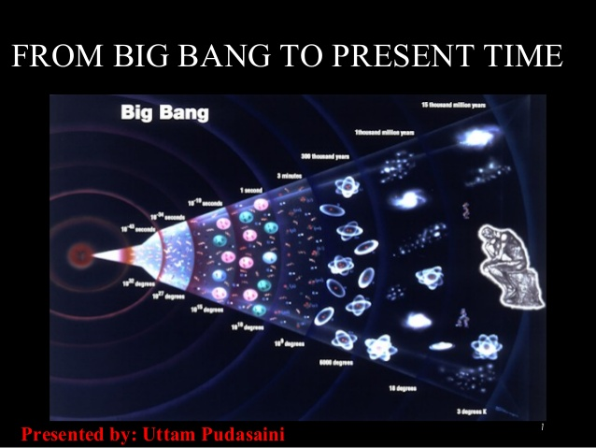
The universe is composed of all matter and energy that exists in… the…. universe/world/existance. All asteroids, moons, planets stars and galaxies are ever ex p a n d i n g, moving away from each other in very high speeds into the nothingness of space. However, if you rewind time, all the universal bodies will start moving towards each other at high speeds. Rewind time far back enough (approximately 15 billion years), everything that exists will become one single point in space-time; an incredibly small point smaller than an atom. This small point ”exploded” due to tremendous amounts of energy; the big bang! This was the beginning of our universe, or that’s what the “Big Bang Theory” suggests.
To give you a better perspective, watch the following YouTube videos:
https://www.youtube.com/watch?v=DmUiCweDic4

https://www.youtube.com/watch?v=HdPzOWlLrbE

https://www.youtube.com/watch?v=wNDGgL73ihY

Now that you have learned about the events in the time-line of the Big Bang, you should be able to put together a timeline of the events that occurred. You are to create a timeline in whatever style of art that can communicate your understanding of the Big Bang.
- Graphic novel style
- Kids cartoon style
- Realistic space style
- Vintage style
- Stick-man style
- Copy-paste collage style
- Others….

In whatever style you choose, your timeline must
- be visually appealing
- have major events in clean, neat text (you need at least 8 major events)
- have dates of each event
- have the temperature in Kelvin of each event
- have visual display of each event
To help you, you may use online resources of your choosing or use the following URL to use the “time machine” and find the events and visual display as a guide. You can use this, but it should not be your ONLY source.
http://resources.schoolscience.co.uk/PPARC/bang/bang.htm

You will be marked on:
- The accuracy of your timeline (dates/temperature/events are accurate)
- The number of important facts you include (the right amount of facts)
- The visual communication (do your visuals communicate and display your facts)
- The overall flow of the timeline (does it flow from one event to another or is it confusing)
If you like, use the following chart to help organize your thoughts and events
Major Event | Date | Temperature (Kelvin) | Info/visual display?
1.
2.
3.
4.
5.
6.
7.
8.
9.
10.

