Biomes of Earth Name:
Block:
Use the readings to answer the questions below.
- Define the following words:
  - Biome:________________________________________________________________________________________________________________________________________________________
  - Biotic Factors:___________________________________________________________________ _______________________________________________________________________________
  - Abiotic Factors: _________________________________________________________________ _______________________________________________________________________________
- What are the 8 different terrestrial biomes on earth?

- What are the 2 factors that determine the type of biome?

- What are the 3 mechanisms on earth that affect the 2 factors named above? Describe each. Use diagrams if it helps
Mechanism | Description of how it can impact the 2 factors in #2
- Use the table below to summarize the various biomes on earth
Biome | Locations | Physical Features
- Colour the world map below with the correct biomes

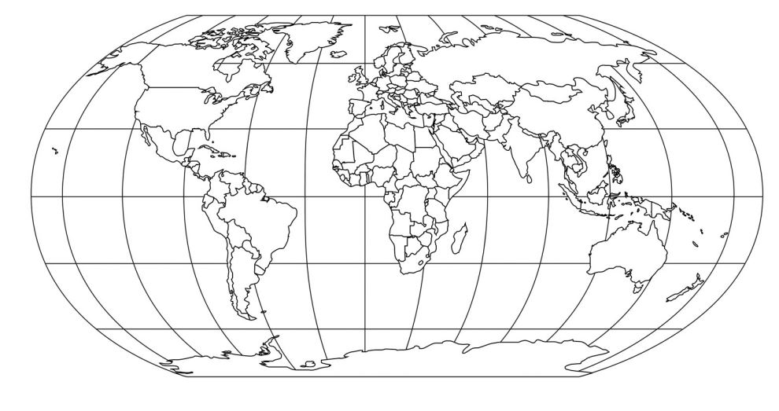

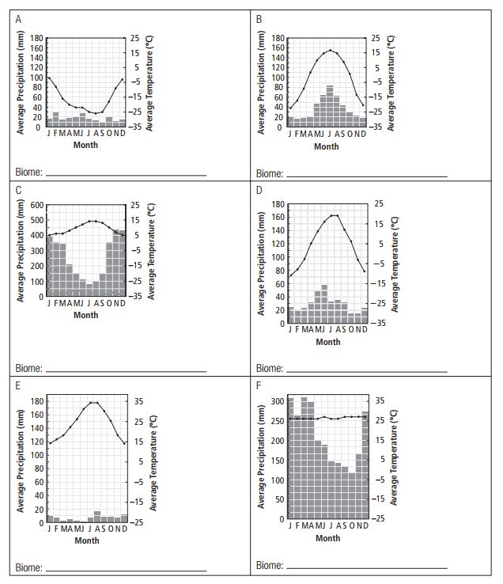
- Determine which biome each of the Climatographs below belong to.

