Chemistry Review From Grade 9 Name:
Block:
Work individually or in groups to answer the questions below. Some might be easier than others, but the point is you start to remember the Chemistry you learned from last year.
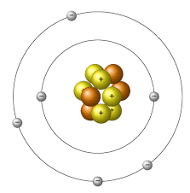
- Label the following parts of the atom with the words on the right. Then complete the table that follows.
Word bank
Proton, Neutron, Electron, shell, nucleus

Name of subatomic particle | Location in atom | Charge | mass
Proton
Neutron
Electron

- Look at the symbols and atomic numbers of the elements.
  - What is the atomic number of helium?

  - What is the atomic number of gold?

  - What is the symbol of the element with atomic number 22?

  - What is the symbol of the element with atomic number 33?

- Look at the atomic masses of the elements.
  - What is the atomic mass of aluminum?

  - What is the atomic mass of silver?

  - What is the symbol of the element with atomic mass 40.1?

  - What is the symbol of the element with atomic mass 83.8?

- What is the difference between an element’s atomic number and its atomic mass?

What is the significance of the atomic number in terms of the periodic table?

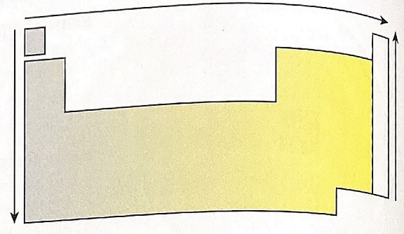
- Use the diagram below to answer the questions that follow.
grey
yellow

  - What physical properties do the grey-shaded elements have in common?

  - What physical properties do the yellow-shaded elements have in common?

  - What physical properties do the elements in the while column have in common?

- Elements 1, 3, 11 and 19 are in the first column of the periodic table.
  - Draw Bohr diagrams for these elements (electron arrangement 2, 8, 8, 18, 18, 32, 32..)
  - How is the electron arrangement in these elements similar?

  - How many electrons would you expect there to be in the outer energy shell of the elements Rb and Cs? Explain.

- Look at the elements 3 to 10.
  - Draw the Bohr Diagrams for these elements. (for this question, you can write the number of electrons in each shell instead of actually drawing them)
  - Compare your diagrams. How are they the same? Different?

  - What period do these elements belong to?

  - What is the relationship between period number and occupied energy shells?

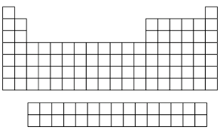
- Colour the periodic table below labelling the families. What are the characteristics of each family? (you may not “remember” this from last year, so do a quick google search)

Colour | Family | Characteristics

