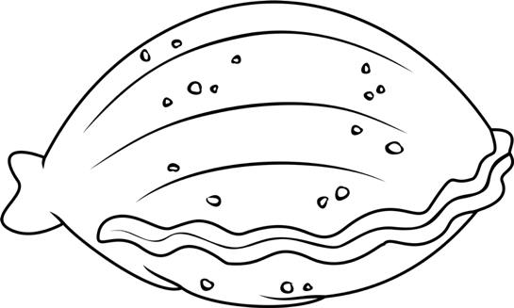
Clam Dissection
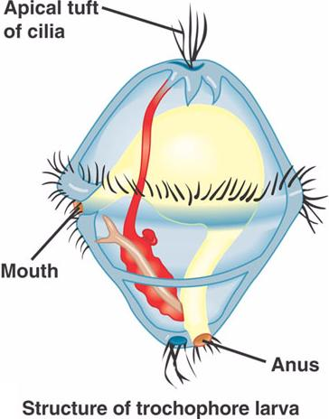
Introduction
Phylum Mollusca includes snails, clams, chitons, slugs, limpets, octopus, and squid. As mollusks develop from a fertilized egg to an adult, most pass through a larval stage called the trocophore. The trocophore is a ciliated, free-swimming stage.

Mollusks also have a radula or file-like organ for feeding, a mantle that may secrete a shell, and a muscular foot for locomotion. Clams are marine mollusks with two valves or shells. Like all mollusks, a clam has a mantle which surrounds its soft body. It also has a muscular foot which enables the clam to burrow itself in mud or sand. The soft tissue above the foot is called the visceral mass and contains the clam's body organs.
Objective
To study the internal and external anatomy of a bivalve mollusk.
Materials
Dissecting pan, dissecting kit, screwdriver, lab apron, safety glasses, preserved clam
Procedure
1. Put on your lab apron & safety glasses.
Part I :EXTERIOR
2. Place a clam in a dissecting tray and identify the anterior and posterior ends of the clam as well as the dorsal, ventral, & lateral surfaces. Then hinge (where the clam shells are connected) is the dorsal side and the opposite side is the ventral side. The dorsal side has a bump is closer to the anterior side. This bump is called the umbo. This is the oldest part of the clam shell. Find the hinge ligament which hinges the valves together and observe the growth rings.

Label the bolded words above on the external body diagram

The left valve is on top if your clam is correctly positioned. The siphons are at the posterior end. If the siphons are not visible, determine which is the ventral side by using the umbo. The umbo is the bump on the top of the shell. It leans toward the anterior end. Notice that the siphon is actually made of two siphons. If you cannot see the siphon now, remember to look closely at it after you open the shell. The ventral siphon carries water into the shell and the dorsal siphon removes the water.

Part II : OPENING OF CLAM
4. Turn the clam with its dorsal side down and insert a screwdriver between the ventral edges of the valves. Carefully work the tip of the screwdriver between the valves (opposite the umbo) so you do not jab your hand.
5. Turn the screwdriver so that the valves are about a centimeter apart. Leave the tip of the screwdriver between the valves and place the clam in the pan with the left valve up.
6. Locate the adductor muscles. With your blade pointing toward the dorsal edge, slide your scalpel between the upper valve & the top tissue layer. Cut down through the anterior adductor muscle, cutting as close to the shell as possible.
The shells are held together by two muscles called the anterior and posterior adductor muscles. Remove the left shell by inserting the scalpel blade between the shell and the mantle and cutting the adductor muscles away from the left shell. (The mantle is the very thin curtain of tissue that lines the inside of the shell. It is responsible for secreting the shell). It is important to keep the blade against the shell so that you are scraping the adductor muscle off the shell more than cutting it. If the shells are still tightly shut, you will have to work the scalpel blade in between the shells carefully. Get help from your instructor if you are having difficulty.
7. Repeat step 6 in cutting the posterior adductor muscle.

8. Lebel the bolded structure above on Figure 2 (opened clam).

9. Bend the left valve back so it lies flat in the tray.
Once both adductor muscles have been cut away from the left shell, the shell can be opened easily. As the shell is opened, the mantle should be pushed away from the shell so that it is not torn. You can remove the left shell to get it out of the way if you want.
10. Run your fingers along the outside and the inside of the left shell and compare the texture of the two surfaces.
11. Locate the muscle "scars" on the inner surface of the left shell, which the adductor muscles were attached here to hold the clam closed.
12. Identify the mantle, the tissue that lines both shells & covers the soft body of the clam. Find the mantle cavity, the space inside the mantle.

Part III : INTERIOR
13. Locate two openings on the posterior end of the clam. The more ventral opening is the incurrent siphon that carries water into the clam and the more dorsal opening is the excurrent siphon where wastes & water leave.
The large muscle attached to the siphons is called the siphon retractor muscle. There would be another one on the right side. These muscles pull the siphon in. Most clams can retract the siphons completely into the shell. Some large clams like the Geoduck have such a large siphon that it doesn't fit into the shell. The siphon brings water into the clam so the siphons have to reach from the clam's body to the water. If the clam is buried 15 cm below the surface, the siphons would have to be able to stretch that far.
The more ventral opening is the incurrent siphon that carries water into the clam and the more dorsal opening is the excurrent siphon where wastes & water leave.

14. With scissors, carefully cut away the half of the mantle that lined the left valve. After removing this part of the mantle, you can see the gills, respiratory structures that are feather like.
The next step is to remove the left mantle along with the siphon retractor muscle. Cut the mantle away with a scalpel. Be careful not to cut the gills. Lift the mantle up as you cut and notice how thin it is. Removing the mantle exposes the gills and the foot. You can see the visceral mass better now as well. In clams like the one pictured, the labial palps are close to the anterior adductors muscle. The labial palps are two flap-like structures that are close to the mouth. Notice the structure of the gills. Bivalves are filter feeders. The gills are used to strain plankton out of the water, as well as to remove oxygen from the water. There is another pair of gills on the right side of the clam.

15. Observe the muscular foot of the clam, which is ventral to the gills. Note the hatchet shape of the foot used to burrow into mud or sand.
16. Locate the palps, flaplike structures that surround & guide food into the clam's mouth. The palps are anterior to the gills & ventral to the anterior adductor muscle. Beneath the palps, find the mouth.

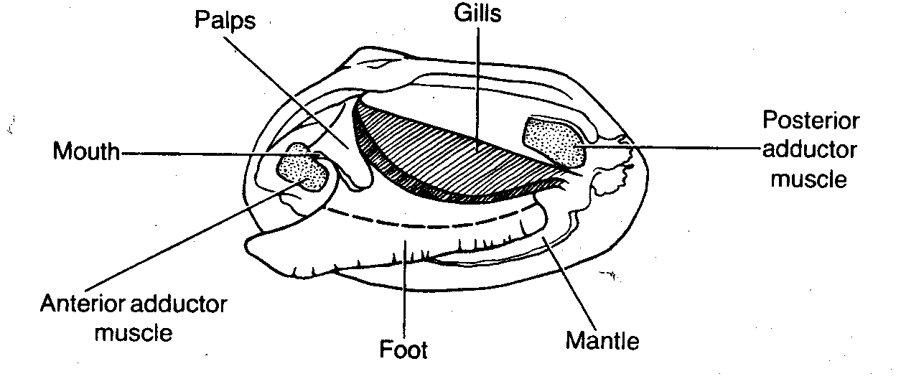

Part IV : IF THERE’S TIME

17. With scissors, cut off the ventral portion of the foot. Use the scalpel to carefully cut the muscle at the top of the foot into right and left halves.
18. Carefully peel away the muscle layer to view the internal organs.
19. Locate the spongy, yellowish reproductive organs.
20. Ventral to the umbo, find the digestive gland, a greenish structure that surrounds the stomach.
21. Locate the long, coiled intestine extending from the stomach.
22. Follow the intestine through the clam. Find the area near the dorsal surface that the intestine passes through called the pericardial area. Find the clam's heart in this area.
23. Continue following the intestine toward the posterior end of the clam. Find the anus just behind the posterior adductor muscle.
24. Use your probe to trace the path of food & wastes from the incurrent siphon through the clam to the excurrent siphon.
To see where the heart is located look above the visceral mass above the gills. There is a clear looking region near the top of the clam. The heart is contained in a thin-walled sac called the pericardium. To get a better view of this region, take the clam out of the shell so you can look at the dorsal side. The clam should come out of its shell fairly easily if you cut the adductor muscles away from the right shell. Looking down on the dorsal side will enable you to see the pericardium. The tube-like structure that runs through the pericardium is the intestine.
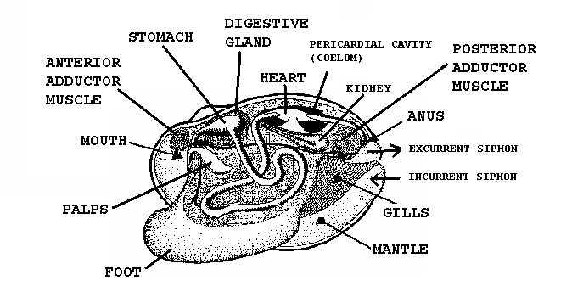

25. Answer the questions on your lab report & label the diagrams of the internal structures of the clam. Also, use arrows on the clam diagram to trace the pathway of food as it travels to the clam's stomach. Continue the arrows showing wastes leaving through the anus.

13. Label the internal structures of the clam and draw arrows
showing the pathway of food as it travels to the clam's stomach:

Exterior Diagram
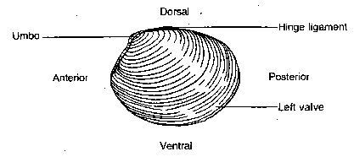

Figure 2 (opened clam)

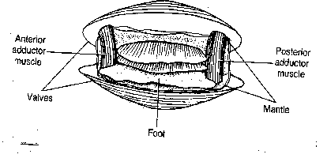

Interior Diagram
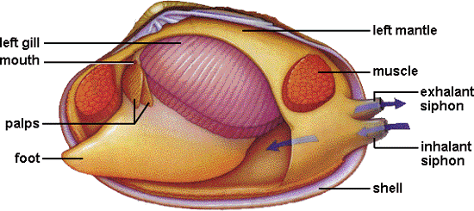

Clam Dissection Questions
Lab Questions:
1. Give the kingdom, phylum, and class for the clam.
2. Give several examples
3. What is the mantle and give its function?
4. What controls the opening and closing of the clam's shell?
5. How do clams feed?
6. What is the oldest part of a clam's shell called and how can it be located?
7. Where are the incurrent & excurrent siphons located and what is their function?
8. How do clams breathe?
9. Describe the shape of the clam's foot and why is it that shape?
10. Where are the palps found and what is their function?
In the space below, describe any surprises of learning that you had through interacting with this dissection.
_____________________________________________________________________________________________________________________________________________________________________________________________________________________________________________________________________________________________________________________________________________________________________________________________________________________________________________________________________________________________________________________________________________________________________________________________________________________________________________________________________________________________________________________________________________________________________________________________________________________________________________________________________

