Weather and Climate Summary Sheet Name:
Block:

- Using a diagram show AND explain how different parts of the earth receive different amounts of energy from the sun.

Earth
sun

- What is albedo and how does it affect energy absorption?

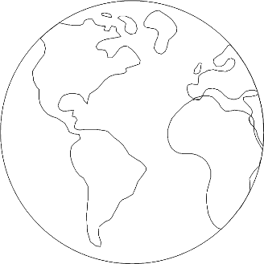
- Use colours to show the heat gradient on the earth.
Label where heat is lost more and less.

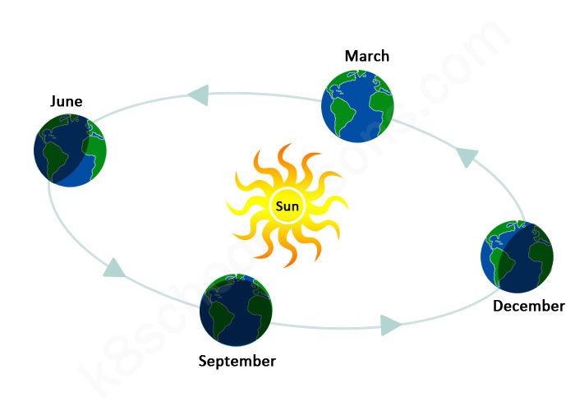
- In the diagram below, label (1)the seasons, (2)the length of day compared to the length of night, (3) the amount of energy received, (4)the solstices and equinoxes.

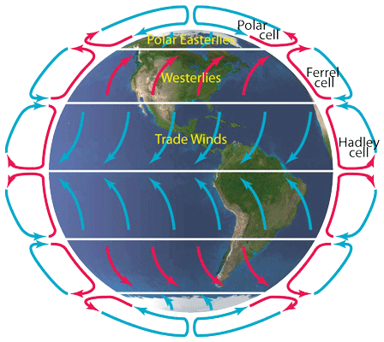
- Below is the diagram of the convection cells that create general weather systems on earth. (1)Describe why each these cells(hadley, polar, ferrel) work the way they do and (2) how they contribute to the dispersion of moisture/rain (Think density, moisture, cooling)

- What is the Coriolis Force?

- How does the Coriolis Force contribute to Jetstreams?

- In the diagram below, draw the jetsreams on earth

