Cnidaria Overview Name:
Block:

- List the main characteristics of cnidarians.

- Describe each “organ system”

Respiratory

Digestive

Circulatory

Nervous

Reproductive

- Label the diagram below

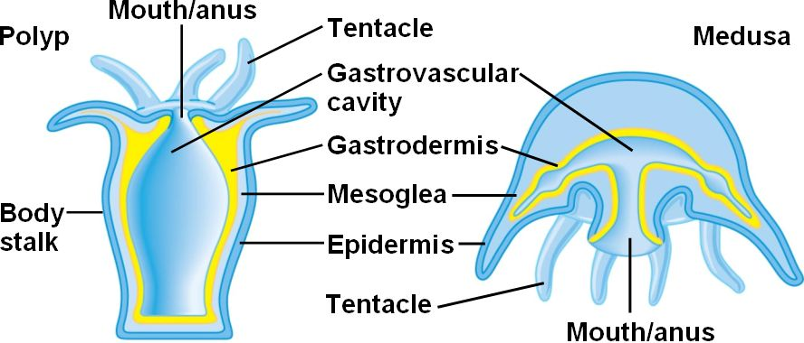

- Label the life cycle of the moon jelly below and describe each step.
