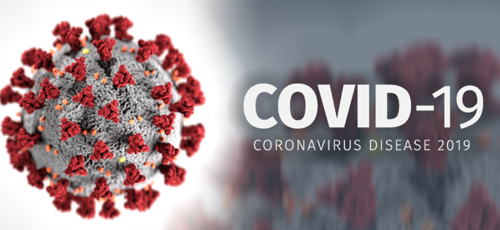
COVID-19 – An Overview

PART 1
Watch the videos below for
Eyewire.news
https://www.youtube.com/watch?v=PSnSo9kYlH4 (1.5min)
https://www.youtube.com/watch?v=BtN-goy9VOY&t=26s (8.5min)

Questions:

- What is COVID-19 made up of?
- Why is COVID-19 so dangerous (much more dangerous than the typical flu)
- What kinds of cells actually damage the sick person’s body?
- Why is it so dangerous for many people to be sick with it at the same time?
- What can we all do to slow the spread of it?

PART 2
Explore the BC COVID-19 Dashboard for the latest data on how our province is experiencing this pandemic.
https://experience.arcgis.com/experience/a6f23959a8b14bfa989e3cda29297ded

Questions:

- Looking at the map, which “Authority” district do we belong to?
- Which Authority has to most number of “total cases”?
- Which age groups are testing positive the most?
- The middle-right graph on the bottom shows the number of positive cases by region, are the cases increasing or decreasing?
- THINK QUESTION: The data shows the number of cases as TESTED by health authorities. One of the most dangerous characteristics of this virus is that many will be asymptomatic, while still carrying it and transmitting it. Knowing these two factors, why are we being so cautious when we are in crowded public places like school?

PART 3
Lab activity : Virus transmission

Materials:
1 small cup per student
Tap water
Phenolphthalein indicator (2 drops per student)
20ml of 1M NaOH solution

Safety: DO NOT touch or drink any of the liquid at any time, just follow instructions.
Procedure:
- Receive your cup of water from your teacher. (1 cup will have the virus – NaOH)
- Move around the classroom and meet and greet your classmates. This is the time to make new friends! Every time you spend time with someone chatting and getting to know them, mix your cup of water with their cup of water (person 1 empties their cup into person 2’s cup, then person 2 pours half of the mixed water back into person 1’s cup)
- Make 5 to 7 new friends (don’t spend more than 2 min with each person)
- After this friend making session, your teacher will go around and put a few drops of phenolphthalein indicator into your cup. Those people with pink liquid in their cups are now positive for the virus.
- Clean up: liquid can be emptied into the sink and cups in the garbage or as instructed by the teacher.
Questions:
- At the end, did you test positive for the virus?
- How many people tested positive?
- Did you know who had the “infected” water in the beginning?
- How did the virus end up in so many cups?
- If we knew who had the “infected” cup, could we have changed the results? If so, how?

Ethical (discussion) Questions:
- If we knew who had the “infected” cup, should we have shamed them? Was it a choice or luck?
- If we did isolate and/or shamed the one person, would this person be more likely or less likely to lie about “symptoms” if the experienced them? How would lying about symptoms affect the final results?
- More people got infected with the virus, was it a choice or was it luck? Is everyone at equal risk of getting an “infected” cup?
- Let’s assume that wearing a mask and social distancing in addition to following health protocols reduces or eliminates the mixing of the water in the cups. How would the results be different if everyone followed the safety precautions?
- WELL DUH Questions: Let’s assume that NO ONE had an infected cup; everyone had JUST water in their cups, but no one knew that fact. Would wearing a mask and following health protocols be worth it? Discuss how it is or it isn’t.

