DNA – the Blueprint of life Name: .
Block: .

- DNA stands for _________________________________________.

- Describe the structure of the DNA in point form.
______________________________________________________________________________________________________________________________________________________________________________________________________________________________________________________________________________________________________________________________________________________________________________________________________________________________________________________________________________________________________________________________________________________________________________________________________________________________________________________________________________________________________

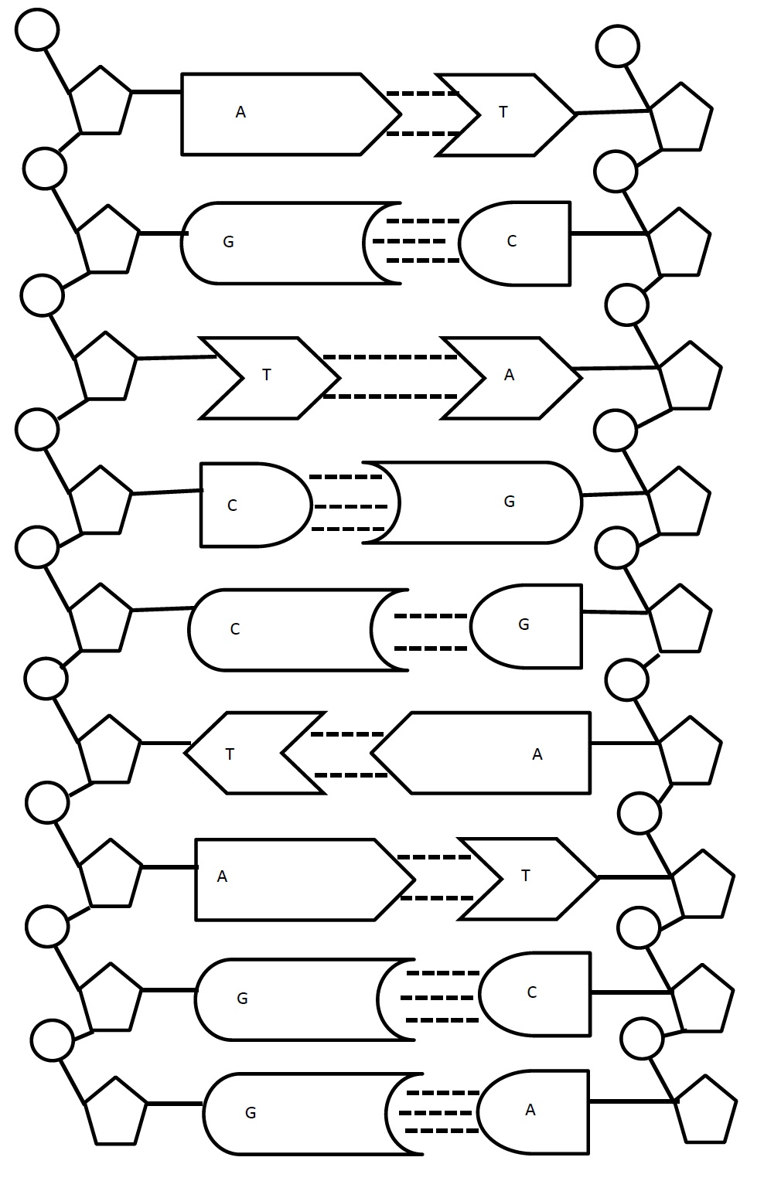
- Label and Colour the structure of the DNA below.
Words to label: Phosphate, Sugar, Phosphate-sugar backbone, nitrogen base, nucleotide, hydrogen bonds, covalent bonds, Adenine, Thymine, Guanine, Cytosine

- If one side of the DNA has the code ATTGCGGATCGTGAATT, what is the complimentary code on the other side of the DNA ?

- What is the name of DNA that is stored in a condensed form in the nucleus of the cell?

- What is a gene?

- What is an allele?

- How are dominant and recessive alleles related?

- If the code for purple flowers is GGCGGTATGC and the code for white flowers is CCGTTATTAT, then
  - Which combination of the alleles above produces purples flowers? (write combinations below)

  - Which combinations of the alleles above produces white flowers? (write combinations below)

- Compare Mitosis and Meiosis briefly below. Use the words haploid and diploid in your answer.

