Environmental Science 12

Welcome to Environmental Science 12!
Overview:
This course reviews that environment we live in and our interactions with it. This is a relatively new and growing science and has a growing number of career paths for those who like to pursue it in post secondary. These careers range from green energy development and technology, to education and environmental justice.
Topics:
The “big ideas” or units we will be covering in this course are:
- Human actions affect the quality of water and its ability to sustain life
- Human activities cause changes in the global climate system
- Sustainable land use is essential to meet the needs of a growing population
- Living sustainably supports the well-being of self, community, and earth.

Through these units you will learn the curricular competencies as outlined in the BC curriculum. You will be assessed on not only the content of the units outlined above, but also the curricular competencies below.
- Questioning and Predicting
- Planning and conducting
- Processing and analyzing data and information
- Evaluating
- Applying and innovating
- Communicating

You will be assessed on the above competencies and big ideas based on small quizzes, research projects, labs and action projects. You will be asked to work individually but also in groups, so start making new friendships.
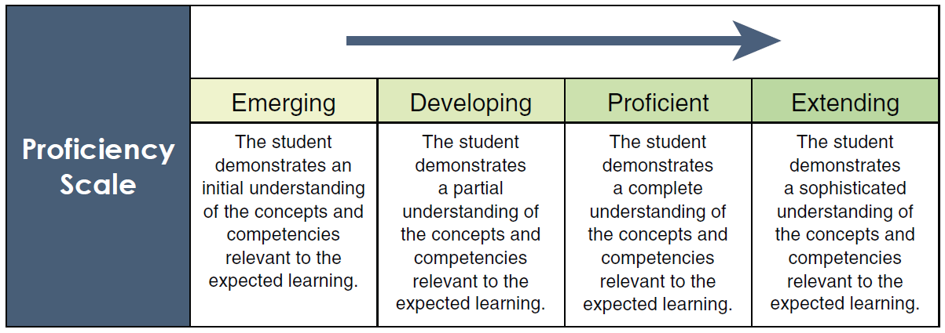

Each project and lab will have their own rubrics and expectations, but the following will give a general understanding of the marking scheme.

Classroom rules and expectations:
This is grade 12.
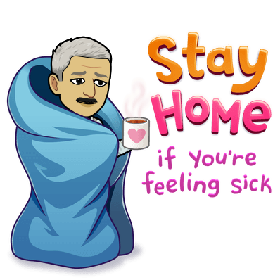
- You are expected to take responsibility for your own learning.
- You are expected to be in class and on time unless of sickness or exceptional circumstances.
- Bring your own material and ask to borrow what you need for the day.
- Form a study group
- Practice and study a little every day
- Ask questions and ask for help when you need it.
- Use your phone appropriately

Communication and assignment submissions
We will be using Microsoft Teams for communication and assignment submissions. It is highly recommended that you download the app on your phone or the software for your computer at home to submit assignments efficiently. Please note that your teacher has a life outside of school and may not reply to your last-minute messages at midnight.

Mr. Ferdosian’s contact info
Email: Moein_ferdosian@sd42.ca
Website: moeinferdosian.weebly.com (currently not up to date with this course)
Microsoft teams chat

