Environmental Science 12 Name:
Block:
Water Cycle in the Greater Vancouver Region.

- Complete the water cycle diagram below by placing the right phrases in the water STORES and PROCESSES
Precipitation  Transpiration  Melting  Run-off | Water in air  Ice/Glacier  Biosphere  Evaporation | Salt water  Fresh water  Underground water  Water in soil  Clouds

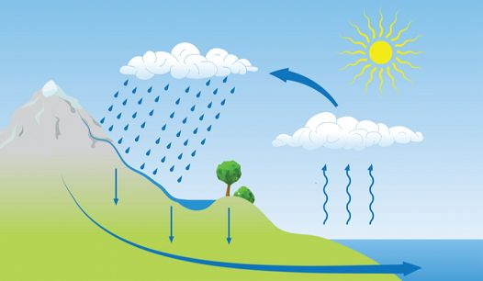

- Research the water cycle in the Greater Vancouver Region
Below is a map of the Greater Vancouver Region. Research the physical features that contribute to the water cycle in the region. Label the list below
- Mountains  - Lakes  - Rivers  - Dams | - Water reservoirs  - Glaciers  - Waster Water treatment centres  - Drinking water treatment centres

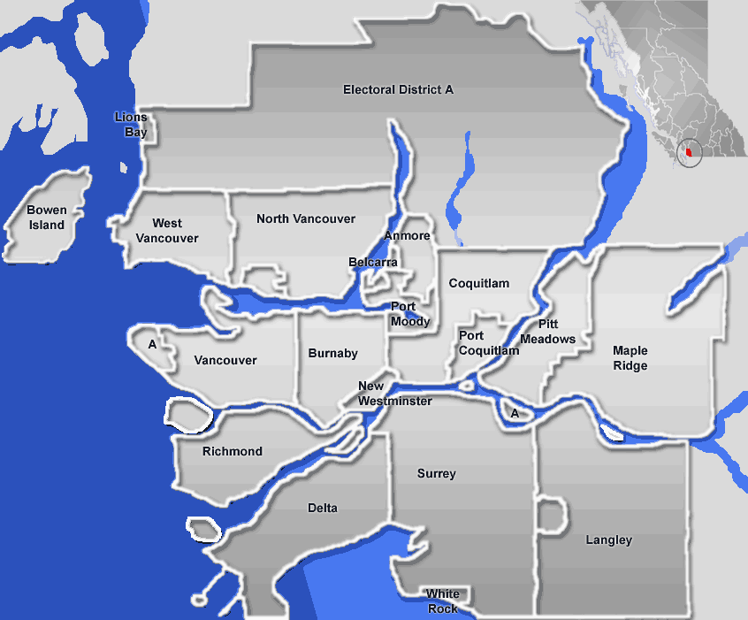

- Where do you get your drinking water from?

- Where do you get water from to water your garden in the summer?

- Where does your shower and toilet get water from to flush/clean?

- Where does your water end up going after you flush it?

