Environmental Science 11/12 Couse Overview

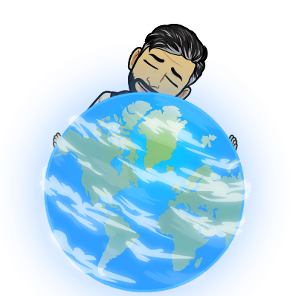
Welcome to Environmental Science! This course is designed to give you the knowledge and skills that are the foundation of future studies in Environmental Sciences, Ecology, Conservations Biology, Physical Geography, Sustainability and more. . . In this course we will be learning about the following Big Ideas:
- Complex roles and relationships contribute to diversity of ecosystems
- Changing ecosystems are maintained by natural processes
- Human practices affect the sustainability of ecosystems
- Humans can play a role in stewardship and restoration of ecosystems

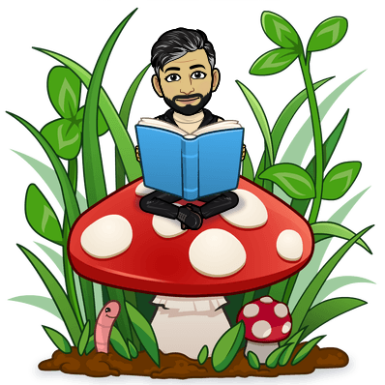
Through the Bid Ideas above we will be learning the following Curricular Competencies:
- Questioning and predicting
- Planning and conducting
- Processing and analyzing data and information
- Evaluating
- Applying and innovating
- Communicating

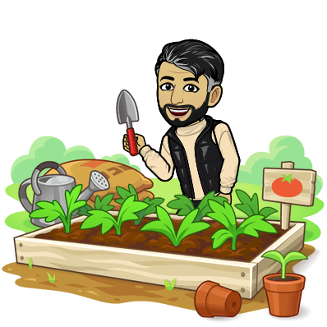
Activities
This class will be combination of
- learning new content
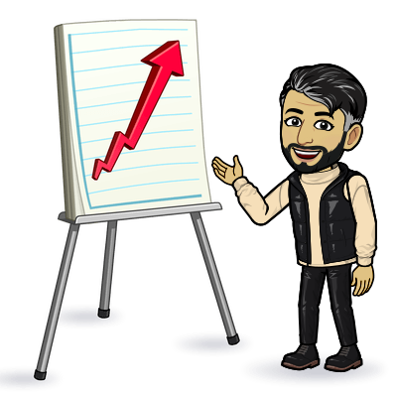
  - that will be tested
  - through research
  - through presentations
- applying learning to
  - conduct action projects
  - teach others
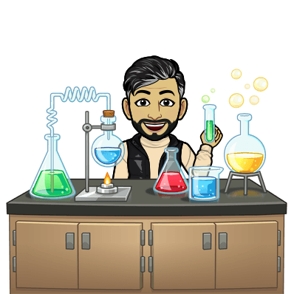
  - come up with experiments
- Conducting labs to
  - Learn new content
  - Test hypotheses we learn in class
  - Analyze data
- Debates on ethical and moral considerations

Expectation:
This is a grade 11/12 Science course that requires students to put in the effort that is required for ANY senior Science course:
- Be present every day and if you miss a day YOU ARE RESPONSIBLE to catch up on missed work
- Be engaged in all class activities, not matter how trivial you may THINK it is
- Complete the work and activities that are assigned even if they are not “worth marks.” There is a reason why your teacher has chosen those activities
- Be prepared to learn every day and have a positive attitude (we all have bad days)
- Make new friends and be part of a group. This course requires a lot of group work so you need to build your social skills.
- Ask for help when you need it. We all need help sometimes and some more than others. It is your responsibility to advocate for yourself when you need help on an assignment, or when there’s “drama” in your group. It is the teacher’s job to help you when you need it.

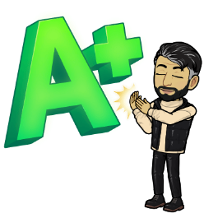
Grades:
This course has a variety of assessments: Tests, Research Projects, Research Presentations, Action Projects, and Labs. Each assignment will have a rubric that will be handed out with the assignment. Generally speaking you will be graded with a rubric that aligns with what’s below.
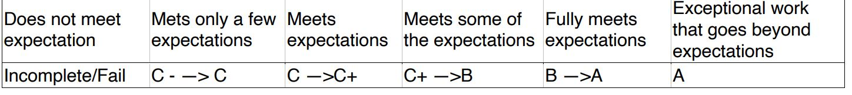

Communication:
You will be using MS Teams for all communication and submitting digital assignments, so be able to log in and TURN ON YOUR NOTIFICATIONS!
