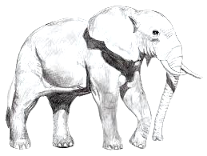
Final Animalia Project Name:
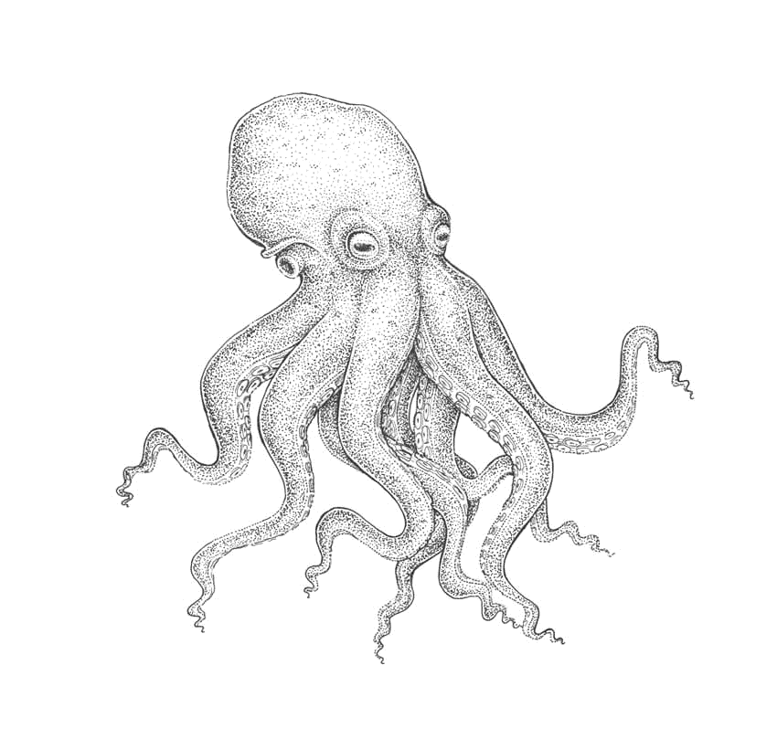
Now that you have learned about the different animal, you are to create a project that looks at the ecological importance of one of these phyla.
- Pick a group within one of the phyla, it can be a small group like octopi, or a large group like insects, or it could the whole phylum.
- Research their
  - evolutionary history
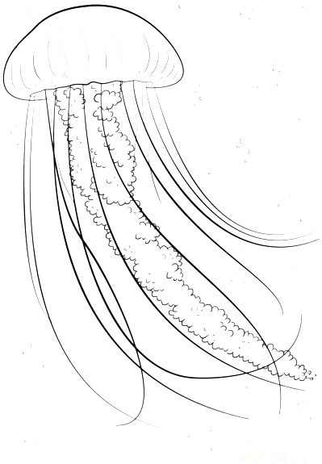
    - When did the phylum begin, what were the ancestors that gave rise to this phylum, what kind of extinction and evolutionary events have they gone through to be currently where they are in the ecosystem of the earth.
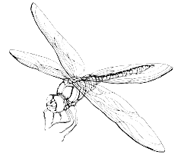
  - ecological importance (historically or currently or both)
    - Why are they important in the ecosystem, why were they important in the ecosystem, what niche do they occupy, what would happen if they were to disappear.
  - the way human activities have impacted their survival and their role in the ecosystem
    - How has our life impacted them, could be historical (eg. We hunted some species to extinction) or it could e current (habitat destruction for many species)
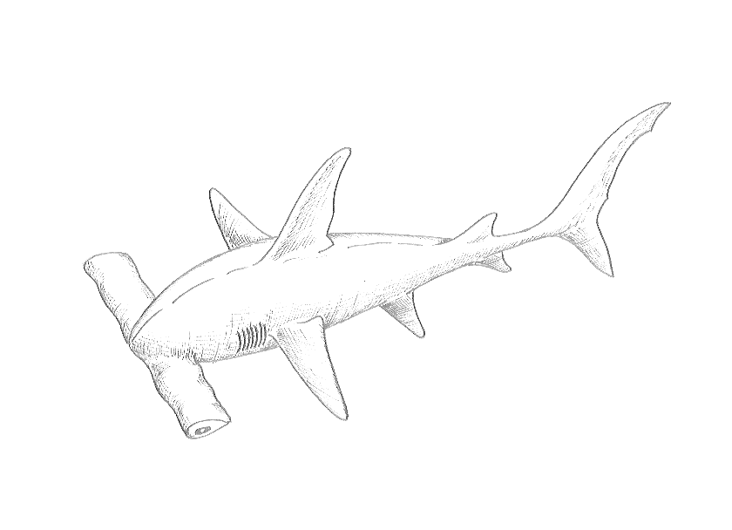
  - the ways in which we can help reduce our impact on them (systemically or personally)
    - What steps can we take to change our systems to help benefit this group of animals, what steps can we take personally in day to day life that would help benefit this group.

- Put your research in a visually appealing and informative presentation of any kind and post on teams. The point is communication. Your presentation will be displayed on teacher website for others to see.
You will be marked on the following criteria:

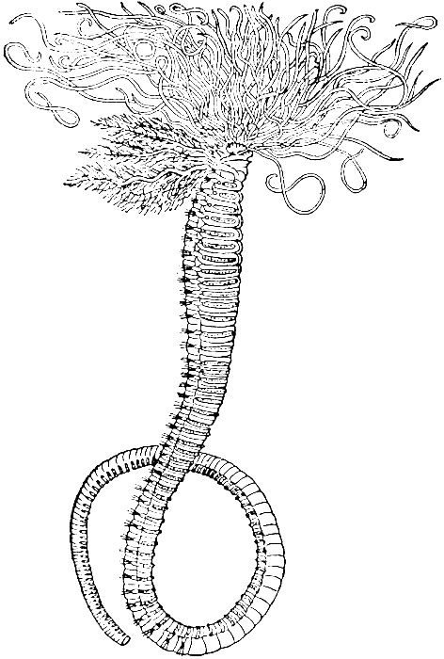
  - Content – To what degree have you covered the topics listed above? Did you just check the boxes or did you go in depth on many of the points?
References – You need to include a bibliography page with at least 5 reliable sources. The bibliography needs to be a consistent format.
  - Communication - How does your project communicate your findings?
Verbal- Words and sentences used should communicate your findings clearly. There should be a natural flow to the project. It can be point form or full sentences, but must be clear, yet not too wordy. How efficiently can you communicate your research?
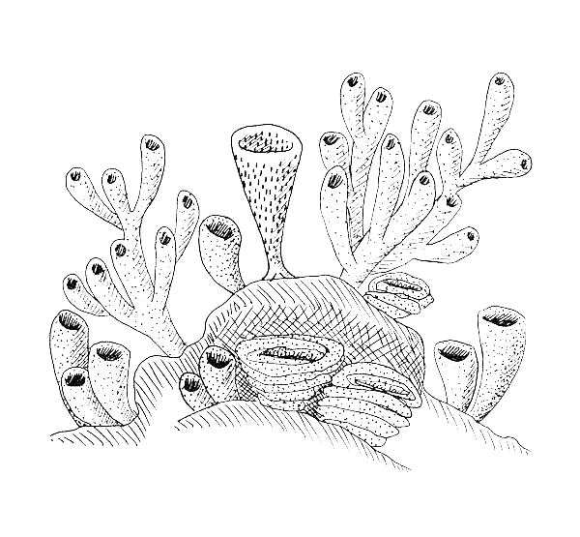
Visual- Do the pictures, diagrams, graphs, tales you used help accompany the verbal communication? How do they add to the clarity of your communication? There can be some for the sake of aesthetics, but they should all be related to what you are communicating.
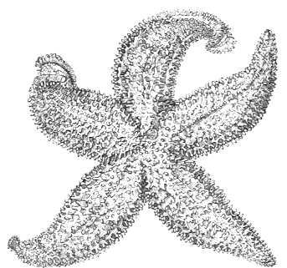
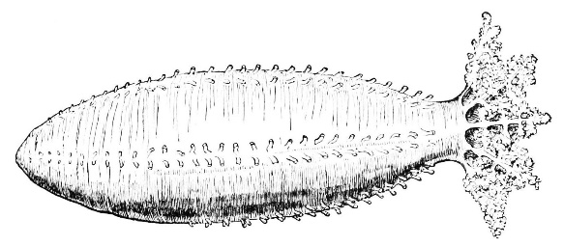
Other – The media through which you are presenting makes sense for the project you have chosen. Does PowerPoint really help you communicate? Does an essay format? Does a video? A poster? Be creative BUT it has to make sense for what you are trying to communicate.

