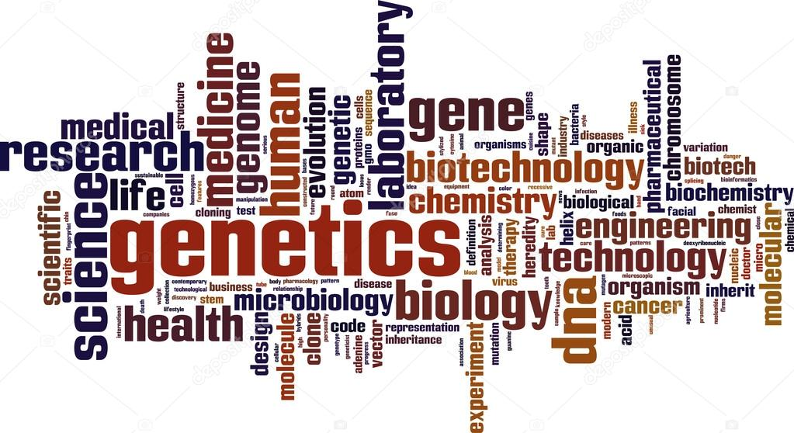
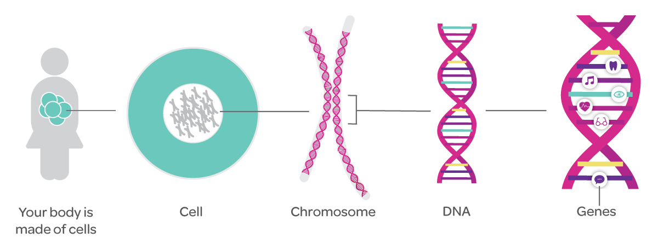
Genetics Work Package

This page is for quick reference notes

Heterozygous -
Homozygous Dominant -
Homozygous Recessive -
Dominant -
Recessive -
Meiosis -
Mitosis -
Monohybrid -

1) For each of the genotypes (AA, Aa or aa) below determine what the phenotype would be. Purple flowers are dominant to white flowers.
PP_____________ Pp ____________ pp _______________
Hairy knuckles are dominant to non-hairy knuckles in humans.
HH_____________ Hh ___________ hh _________________
Bobtails in cats are recessive. Normal tails are dominant.
TT _____________ Tt ____________ tt _____________

2) For each of the following write whether it is homozygous dominant, heterozygous or homozygous recessive.

AA _____________________
gg ______________________
Pp ______________________
Ii _______________________
tt _______________________
TT ______________________

Crosses with one homozygous dominant parent:
AA x AA AA x Aa AA x aa
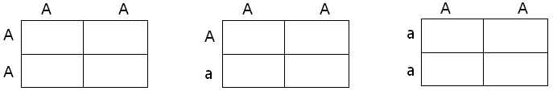

Offspring Genotypes:
AA Aa aa AA Aa aa AA Aa aa
Offspring Phenotypes:
Dominant Dominant Dominant
Recessive Recessive Recessive

Crosses with one heterozygous parent:
Aa x AA Aa x Aa Aa x aa
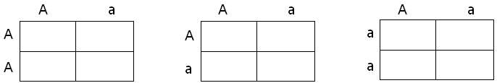

Offspring Genotypes:
AA Aa aa AA Aa aa AA Aa aa
Offspring Phenotypes:
Dominant Dominant Dominant
Recessive Recessive Recessive

Crosses with one homozygous recessive parent:
aa x AA aa x Aa aa x aa
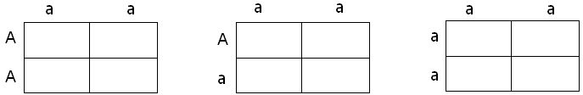
Offspring Genotypes:
AA Aa aa AA Aa aa AA Aa aa
Offspring Phenotypes:
Dominant Dominant Dominant
Recessive Recessive Recessive
Mendelian Dominant Recessive Problems
1. Seed shape in pea plants can either be round or wrinkled. The allele for round shape is indicated by R. Is round seed shape dominant or recessive?

2. The allele for freckles is indicated by F. What is the genotype of a person who is heterozygous for freckles?

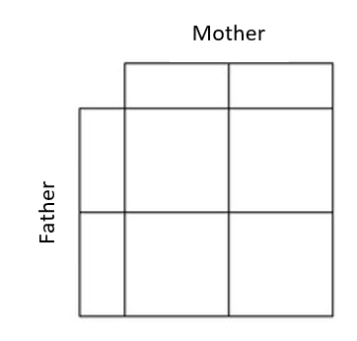
3. Draw a punnett square that represents a monohybrid cross between a female with the genotype Rr and a male with the genotype RR. What fraction of the offspring is predicted to have a phenotype of the dominant trait?

4. In mussels, brown colouring (B) is dominant, and blue colouring (b) is recessive. A homozygous brown mussel crosses with a blue mussel. What percentage of offspring are expected to be blue?

______ % will be blue

5. In sheep the allele for belly fur (A) is dominant to the allele for no belly fur (a). A mother with the genotype Aa and a father with the genotype Aa produce an offspring. What is the percent chance that the offspring will have no belly fur?

____% no belly fur

6. In pea plants, the allele for green pods is dominant (G) and the allele for yellow pods is recessive (g). A homozygous green-podded plant is crossed with a yellow podded pea plant. What are the possible genotypes of the parents (P generations)?
Parent generation genotypes: __________ X __________
Use these genotypes to draw a punnett square and determine the possible genotypes and phenotypes of both the F1 and F2 generations.

F1: Offspring Genotypes:

Offspring Phenotypes:

F2: Offspring Genotypes:

Offspring Phenotypes:

7. In humans, the allele that codes for the ability to taste PTC is dominant (T) and the allele that codes for the inability is recessive (t). A male who is heterozygous for this trait marries a female who cannot taste PTC.
What are the genotypes of the male and female?

Draw a punnett square to show the possible genotypes of the offspring.

What % of their offspring will be able to taste PTC?

8. Two black Guinea pigs were mated and over several years they produced 36 babies. 27 of the babies were black and 9 were white. Use a punnett square to give possible genotypes of the parents and the babies. Be sure to justify your answer.

9. In cats, the allele for short fur (H) is dominant to the allele for long hair (h). A heterozygous short haired cat is crossed with a long haired cat. What percentage of the offspring is expected to be heterozygous for hair length?

10. In watermelons, solid green rind colour (G) is dominant to stripes (g). A farmer crosses two watermelon plants that are heterozygous for rind colour. What are the odds that the offspring will have solid green rinds?

11. In humans, brown eyes (B) are dominant over blue (b). A brown eyed man marries a blue eyed woman and they have three children, two of whom are brown eyed and one of whom is blue eyed. Draw the punnett square that illustrates this marriage. What is the man’s genotype? What are the genotypes of the children?
_Child___Phenotypes___Possible Genotypes
Child #1 brown eyes
Child #2 brown eyes
Child #3 blue eyes

12. The female dog is heterozygous. The male dog is heterozygous. Figure out the phenotypes and genotypes of their possible puppies by using a Punnett Square.
% of possible Genotypes:
FF: ________
Ff: ________
ff: _________

% of possible Phenotypes:
Black fur: __________
Grey fur: ___________

13. In fruit flies, red eyes are dominant (E). White eyes are recessive (e). If the female fly has white eyes and the male fly has homozygous dominant red eyes, what are the possible phenotypes and genotypes of their offspring?

14. Having a widow’s peak like Wentworth Miller is Dominant. Not having a widow’s peak like Rihanna is recessive.
If Wentworth Miller is Aa, and he and Rihanna had children, what are the possible phenotypes and genotypes of their children?

15. Look at the phenotypes of Beyonce and Jay Z. If these two had children, could they have children with a widow’s peak? Why or why not? Use a Punnett Square to explain your answer.
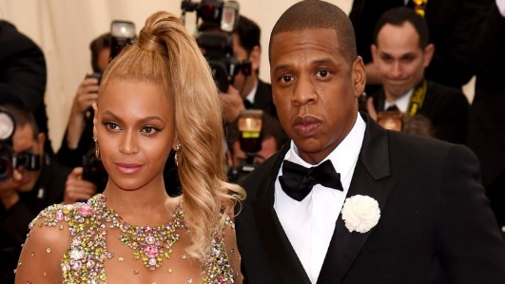

INCOMPLETE DOMINANCE

Bikini Bottom Genetics

Sponge Bob loves growing flowers for his pal Sandy! Her favourite flowers, Poofkins, are found in red, blue, and purple. Use the information provided and your knowledge of incomplete dominance to complete each section below.

1. Write the correct genotype for each colour if R represents a red gene and B represents a blue gene.

Red - __________ Blue - __________ Purple - __________

2. What would happen if Sponge Bob crossed a Poofkin with red flowers with a Poofkin with blue flowers? Complete the Punnett Square to determine the chances of each flower colour.

(a) Give the genotypes and phenotypes for the offspring?

(b) How many of the plants would have red flowers? _____%
(c) How many of the plants would have purple flowers ___%
(d) How many of the plants would have blue flowers _____%

3. What would happen if Sponge Bob crossed two Poofkins with purple flowers? Complete the Punnet square to show the probability for each flower colour.

(a) Give the genotypes and phenotypes for the offspring?

(b) How many of the plants would have red flowers? _____%
(c) How many of the plants would have purple flowers ___%
(d) How many of the plants would have blue flowers _____%

4. What would happen if Sponge Bob crossed a Poofkin with purple flowers with a Poofkin with Blue flowers? Complete the Punnett square to show the probability for plants with each flower colour.
(a) Give the genotypes and phenotypes for the offspring?

(b) How many of the plants would have red flowers? _____%
(c) How many of the plants would have purple flowers ___%
(d) How many of the plants would have blue flowers _____%

5. The trait for coat colour in cats shows incomplete dominance. A) If you cross a white cat (WW) with a black cat (BB) what will be the possible genotypes and phenotypes of their kittens? B) If you cross two grey kittens (BW) what are the possible genotypes and phenotypes of their kittens?

6. When a Snap Dragon homozygous for red flowers is crossed with one homozygous for white flowers, the offspring are pink. Predict the results of combining a pink flower with a homozygous white one. Show all possible genotypes and phenotypes of offspring.

7. For a particular plant, a cross between a purebred variety with blue flowers and a purebred variety with white glowers results in a plant with light-blue flowers. The cross is written as BB(blue) X WW(white) BW (light blue).
a) What kind of dominance is suggested by this result? Explain why.

b) Draw a Punnett square for a cross between two plants with light-blue flowers. Show both the genotype and phenotype of the offspring in each box.

c) If 120 flowers are produced in the F₂ generation from the cross above, predict how many flowers will have the genotypes and phenotypes:
BB - ____________ Blue - __________
BW - ___________ Light-blue - ___________
WW - ___________ White - ___________

8. An imaginary flowering plant with orange petals is crossed with another plant with the same phenotype. The offspring consist of 10 plants with orange petal, 5 plants with red petals, and 5 plants with yellow petals. Suggest an explanation for this pattern of inheritance.

b) A plant with orange flowers is crossed with a plant with red flowers. If 60 offspring are produced, how many plants of each phenotype (red, orange, yellow) are likely to be produced?

Red - ________ Orange - _________ Yellow - __________

CO-DOMINANCE

Human blood types are determined by genes that follow the CODOMINANCE pattern of inheritance.
There are two dominant alleles (A & B) and one recessive allele (O).
Blood Type (Phenotype) | Genotype | Can donate blood to: | Can receive blood from:
O | ii (OO) | A,B,AB and O  (universal donor) | O
AB | I^{A}I^{B} | AB | A,B,AB and O  (universal receiver)
A | I^{A}I^{A} or I^{A}i (I^{A}O) | AB, A | O,A
B | I^{B}I^{B} or I^{B}i (I^{B}O) | AB,B | O,B

- Write the genotype for each person based on the description:
  - Homozygous for the “B” allele _________
  - Heterozygous for the “A” allele _________
  - Type O _________
  - Type “A” and had a type “O” parent _________
  - Type “AB” _________
  - Blood can be donated to anybody _________
  - Can only get blood from a type “O” donor _________
- Pretend that Brad Pitt is homozygous for the type B allele, and Angelina Jolie is type “O.”
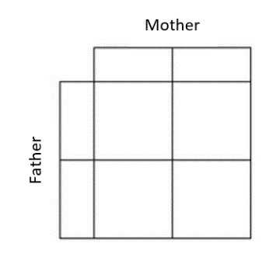
What are all the possible blood types of their baby? (Do the punnett square)

_________________________________________________________________

- Complete the punnett square showing all the possible blood types for the offspring produced
by a type “O” mother and an a Type “AB” father. What are percentages of each offspring?

_________________________________________________________________

- Mrs. Brown is type “A” and Mr. Brown is type “O.” They have three children named Matthew, Mark, and Luke. Mark is type “O,” Matthew is type “A,” and Luke is type “AB.” Based on this information:
  - Mr. Brown must have the genotype ______
  - Mrs. Brown must have the genotype ______ because ___________ has blood type ______
  - Luke cannot be the child of these parents because neither parent has the allele _____.

- Two parents think their baby was switched at the hospital. Its 1968, so DNA fingerprinting technology does not exist yet. The mother has blood type “O,” the father has blood type “AB,”
and the baby has blood type “B.”
  - Mother’s genotype: _______
  - Father’s genotype: _______
  - Baby’s genotype: ______ or ________
  - Punnett square showing all possible genotypes for children
produced by this couple.
  - Was the baby switched? _______________________

- Two other parents think their baby was switched at the hospital. Amy the mother has blood type “A,” Steven the father has blood type “B,” and Priscilla the baby has blood type “AB.”
  - Mother’s genotype: _______ or ________
  - Father’s genotype: _______ or ________
  - Baby’s genotype: ______
  - Punnett square that shows the baby’s genotype as a possibility
  - Could the baby actually be theirs? _________________________

- Based on the information in this table, which men could not be the father of the baby?
You can use the Punnett square if you need help figuring it out.

Name | Blood Type
Mother | Type A
Baby | Type B
The mailman | Type O
The butcher | TypeAB
The waiter | Type A
The cable guy | Type B

- The sister of the mom above also had issues with finding out who the father of her baby was. She had the state take a blood test of potential fathers. Based on the information in this table, why was the baby taken away by the state after the test?

Name | Blood Type
Mother | Type O
Baby | Type AB
Bartender | Type O
Guy at the club | Type AB
Cabdriver | Type A
Flight attendant | Type B

9. A mother has type A blood and her daughter has type B blood. Is it possible that the father has type O blood? Explain your answer.

10. A mother has type A blood, and the father has type B blood. Is it possible for their son to have type O blood? Explain your answer.

11. Three common alleles in human blood types are A, B, o. The o allele is recessive to both the A and the B alleles. Allele A makes a protein that produces molecule A, which attaches to the red blood cell’s membrane. Allele B works the same way, resulting in molecule B attaching to the cell’s membrane. The o allele does not code for a protein, and no molecules attach to the cell membrane. Match each genotype with the appropriate blood type.

a) oo ___________
b) AA ___________
c) Bo ___________
d) Ao ___________
e) BB ___________
f) AB ___________

12. Draw a Punnett square showing a cross between a father with genotype Ao and a mother with genotype AB.

a) What is the probability that the child will have blood type o?

b) What is the probability that the child will be homozygous type A?

13. Mr. and Mrs. Green had a baby the same day as two other couples, the Oranges and the Browns. The Greens began to believe that their baby had been switched at the hospital due to some of her traits. Using Punnett squares and the information provided, solve the problem of the switched babies. Where the babies switched at birth? Which baby belongs to which parents?

Parents | Blood Types | Possible Geno
Mr. Green | A | Ai or AA
Mrs. Green | A
Mr. Orange | O
Mrs. Orange | B
Mr. Brown | AB
Mrs. Brown | AB
Baby | Blood Type | Possible Geno
Baby Green | AB
Baby Orange | A
Baby Brown | O

Who are the real parents of:

Baby Green: __________________ Baby Orange: __________________ Baby Brown: ________________

SEX-LINKED TRAITS

1. What is the sex chromosome pairing for a male? What is the sex chromosome pairing for a female?

2. On which chromosome are the sex-linked genes located in?

3. A female is the carrier of the colour blind gene. She mates with a normal male. They have two boys (one is normal, one is colour blind) and they have 2 girls (one is normal, the other is a carrier).
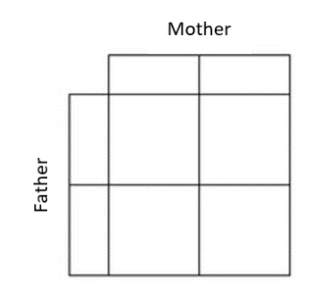
a) draw a Punnett square to show the above results

b) If the carrier daughter marries a colour blind make, what are the chances that their sons will be colour blind? Daughters colour blind?

4. A lady with normal skin texture marries a man who has extremely smooth skin. All four of their children (two boys, two girls) have normal skin. Five out of eight grandsons end up with smooth skin. Explain how this is possible by making use of Punnett squares.

5. Haemophilia is a sex-linked recessive trait. Could a carrier woman have a haemophiliac son?

6. Could a haemophiliac man pass the gene to his sons? Why?

7. Give the offspring Phenotype and genotype ratios for a cross between a haemophiliac man and a homozygous normal woman.

8. The gene for colour blindness is located on the non-homologous portion of the X chromosome. It is recessive.

a) could a carrier woman have a colour blind son?

b) could she have colour blind daughters?

9. The inheritance of eye colour in fruit flies is sex-linked.
X^{R} = Red eye (dominant)
X^{r} = White eye (recessive)

a) Use the symbols above to draw a Punnett square showing the outcome of a mating of a female with one allele for red eyes and one allele for white eyes with a white-eyed male

b) What percentage of the offspring will have white eyes: ___________ red eyes: ________

c) Are the red eyed male offspring able to pass the white eyed trait on to the next generation? Explain your answer.

d) Are the red-eyed female offspring able to pass the white eyed trait on to the next generation? Explain your answer.

10. Hemophilia is a sex-linked trait. What is the possibility that the children of a cross between a carrier female (X^{H}X^{h}) and a normal male (X^{H}Y) will have hemophilia? Will be carriers? Will be normal? Show your work and possible genotypes and phenotypes of their children.

Phenotype(s)

Genotype(s)

11. Colourblindness is a sex-linked, recessive trait in humans. That means it is found only on the X chromosome. Remember that a male is XY and a female is XX. A woman who is a carrier of the colour blindness gene X^{N}X^{n} marries a colour blind man X^{n}Y. They plan on having children in a couple of years. What are the chances that their sons will be colour blind? What are the chances that their daughters will be colour blind? Use a Punnett square to solve this problem.

% of sons that will be CB

% of daughter that will be CB

