Insect Identification Dichotomous Key Lab Name:
Block:

Now that you have learned how to use a dichotomous key, it’s time to practice on real organisms.

Insects belong to the following classification of organisms
Domain: Eukarya
Kingdom: Animalia
Phylum: Arthropoda (Subphylum Uniramia)
Class: Insecta
Order: 30 orders
Family: Many
Genus: Many more
Species: Over 1 million (over 80% of total species on earth)

So, when we talk about insects, we are referring to an ENTIRE CLASS of organisms. Class Insecta is made up of at least 30 discovered/described Orders, each Order consisting of a number of Families, each Family consisting of its own Genuses, each Genus consisting of a number of Species. Needless to say, there are all types of insects in almost every living environment on earth.

What happens when you come across a dead insect in an old lamp shade? Or you see this weird wasp flying around your head and it ends up sitting on your shoulder initiating a full on PANIC ATTACK…? What is it? Is it dangerous? What does it want? Why did it chase me? Why is it dead in a lamp shade?

To answer many of those questions, it would be helpful to know what kind of insect it is. Entomologists (people who study insects) have put together extensive dichotomous keys to be able to identify insects at various levels of classification. One such dichotomous key can be found at https://www.insectidentification.org
At the bottom of the page under “Resources” find “Insect Dichotomous Key” Click on it.
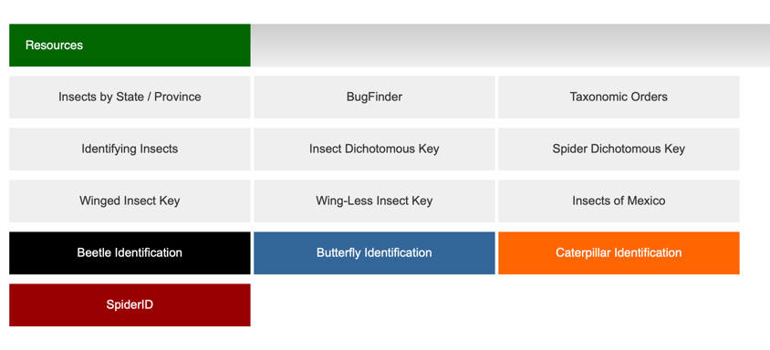

You will be given some real-life (but quite dead) specimens to identify using the dichotomous key. You are to use to dichotomous key to identify them down to their “Order,” but you are encouraged to follow the prompts to identify them down to their species. You are not required to identify them beyond their Order. Use the following pages to record your findings and answer the questions that follow.

Your subjects: What is the organism that you have been given? In Biology, being able to sketch, accurately, not necessarily artistically is a skill that can help you. Accurate, means you draw the important parts (relatively to scale and definitely the right number of limbs). Artistic – you don’t have to make it “look nice” doesn’t have to be realistic.
Sketch your insects in the space below.
Specimen #_____________  Order____________________, Sp. ___________ | Specimen #_____________  Order____________________, Sp. ___________
Specimen #_____________  Order____________________, Sp. ___________ | Specimen #_____________  Order____________________, Sp. ___________
Specimen #_____________  Order____________________, Sp. ___________ | Specimen #_____________  Order____________________, Sp. ___________
Specimen #_____________  Order____________________, Sp. ___________ | Specimen #_____________  Order____________________, Sp. ___________
Now that you have sketched your insect, use the dichotomous key on the website https://www.insectidentification.org to start to identify your insect down to its Order. Under each sketch write down the order to which the insect belongs to.
If you want to identify the insects down to their Species, you can. Write the Latin name or the common name under the name of the order you wrote.

Questions

- Last class you used a dichotomous key to identify “lobster creatures” and “robots”. This class you used a real dichotomous key on real animals. How are the two dichotomous keys different? How was your experience of using them different?

- Which of the insects was/were harder to identify and why?

- What did you learn about insects that you didn’t know before?

- What did you learn about dichotomous keys that you didn’t know before?

- Think about how many species of organisms there are on earth. Dichotomous keys exist for many of them. Dichotomous keys can be good or bad. What features of a dichotomous key makes it good and what features makes it bad?
Features that make it good | Features that make it bad

