Kingdom Animalia Name: .
Block: .

- What makes an animal an animal?

- State the levels of organization of living things.

  - Which level of organization is the heart?
  - Which level of organization is the nervous system?

- Compare and contrast the anatomy of the following:
  - Polar bear and Grizzly bear
 | Compare (similarities) | Contrast (differences)
Polar bear
Grizzly bear

  - Bat starfish and feather starfish
 | Compare (similarities) | Contrast (differences)
Bat starfish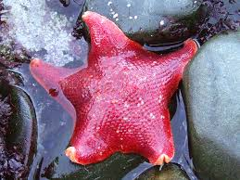
Feather starfish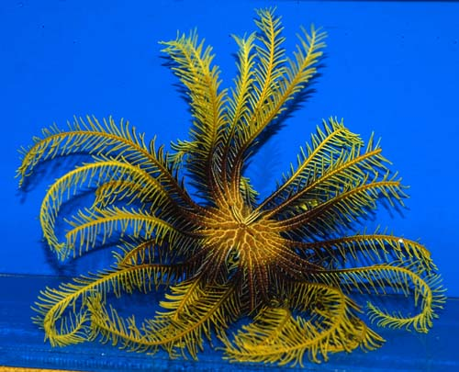

- Describe the structure and function of the following:
 | Structure (what it looks like/made up of) | Function (What does it do, how is its structure related to its function)
Moose’s Horn

Dog’s Canine teeth

Human hands

- What is the difference between an endoskeleton and exoskeleton?

- Define the following:
  - Herbivore:
  - Carnivore:
  - Omnivore:
  - Sessile:
  - Motile:

  - Diffusion:

  - Respiration:

- Determine what kind of symmetry the following have.
  - Lion
  - Starfish
  - Tree
  - Sea sponge
  - Pizza
  - Centepede

- Label the following organism with all the anatomical positioning words.

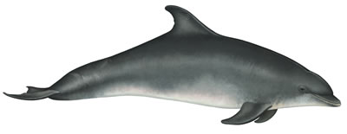

- State the stages of life of an organism from the time of fertilization to its birth. (memorize which is which)

- What are the 3 cell layers?
  - Which layer is your skin?
  - Which layer is your gut lining?
  - Which layer is your bicep?

- What are the three body types in terms of coeloms?

