Learning at home (online)

The following are some ideas to help you manage your online learning at home.
These are just suggestions that you may find helpful to fully use or use parts of it or modify it to suite your needs.
Learning at home and getting instructions online may be fun for some people but for others it can be quite overwhelming and disconnected.
It’s not magic to change all the habits you used to have and to disconnect from the people you used to hang out with all the time. It is a process and it’ll take time.

Here are some things to think about when trying to manage your learning at home and online.
DISCLAIMER – this may not work for you, but if you can take elements of it and use it, then you can be more productive and less overwhelmed.

- Physical Environment
- Set up a physical space at home that is designated for school work
- Try to have the space away from family activities
- Have the space decluttered from non-essential things
- Keep any distractions away from this space
- When you enter this space you should feel safe and focused.
- Troubleshoot (if you don’t have this space available in your house)
  - Can there be a make-shift space? For example, can your dining room table or a corner of your house where there is any table be used certain times of the day? You can move your school things in the space for a period of time then pack up after you’re done.
  - If there are family activities or siblings, who disturb this space, can you have a talk with your family to see what time of the day that space can be yours to use? -Even if it’s for 30min/day.

- Time management & Motivation
- ROUTINE – get one!
- Set up a daily routine at least for the weekdays.
  - Set up alarm daily in the morning (a time that is realistic for you)
  - Have breakfast
  - Go for a walk if you like/check your social media if you like
(DO NOT engage in activities, which drain your energy or require your attention for the next few hours – ex. DO NOT go for an intense run, if you know that you’re going to need a nap after, DO NOT start conversations on social media that require you to respond constantly – END all activities that require your attention)
  - School time – Prioritize which subject and which assignment you’re going to do (see “Organization” below for help on that)
    - Spend enough time to have a good portion of the assignment done and take a 5 min break when you need it, don’t lie to yourself – you know best when you actually NEED a break
  - Lunch – Eat something healthy whenever you have the opportunity to
    - Do something active – something that moves your body
      - Walk/jog/yoga/garden/shoot hoops/sports with siblings
    - Connect with family and friends – tell people that it’s your lunch break and talk to them – in person or electronic, check your social media – post something positive about your day
    - Have a nap if you need one, but set an alarm – multiples of 20min naps are best to my experience
    - Lunch break is to nourish your body and your mind, do something that refreshes you
  - School time – Cut all distractions and continue your work for as long as you can with breaks when you need them.
  - Relax time – do WHATEVER you want! YOU DESERVE IT! You set up a schedule and stuck to it! Do whatever you need to enjoy your day
    - Be aware of your body/mind/soul needs – Are you hungry/thirsty? Is your mind tired? Do you need something mindless to do - A stupid game on your phone? Does your body need to move? Are your muscles sore or stiff? Do you need to lye down? Do you need social connection? Do you need to talk to someone? Do you need to meditate? Would music cheer you up? Have a dance party in your head or out physically? Don’t ignore your body, mind and soul.
  - Evening activities – spend time with family and yourself if you prefer
    - Cook something – From fried eggs to 3 course meal
    - Pick up a new hobby – is there anything you’ve always wanted to do, but never had the time to?
    - Play board games with family
    - Watch a new show
  - Reflect on the day – ALWAYS look back at what you did during the day – pick 2 things that you are proud you did and 1 thing that you would like to change tomorrow.
  - Set up a nightly routine – exclude the phone screen close to bed time – read a new book, start or continue writing in a diary.
    - SLEEP at a reasonable time – if you don’t get enough sleep you will have a hard time keeping up with tomorrow’s schedule

- Organization
- What mode of VISUAL organization works for you? If you don’t know, you NEED to try different things …. like… yesterday.. ASAP!
  - You need a calendar
    - print off the internet (just google “2020 calendar blank”)
    - Blank notebook with each page as one day just label each
    - A paper calendar you already have in the house
    - Your computer calendar
    - Your phone’s calendar
    - You need to put all assignment due dates, test, quiz days on it
  - You need an course list with contacts (see below for sample)
    - Which course, with which teacher, what’s their email, how do I submit assignment
  - You should organize your email inbox
    - Create folders within your inbox with your course name and put all emails from each teacher in the proper folder
    - Check your email daily – even twice a day to keep on top of all emails
  - Have a checklist – paper or on your phone
    - What have you done and what do you need to do next?
      - Checking off things you’ve done will motivate you to get more things done

1. PHYSICAL ENVIRONMENT CHECKLIST
The list below is one that can help you set up an area of the house for your school work. You do not NEED to check off all of it, just he ones that you can.
- Desk in well lit area
- Quiet
- No distractions – No phone if not necessary
- School supplies needed for the day close by
- Water and snacks close by
- Sing on the door saying “Do Not Disturb”
- Family members know the space and time your are there
- Clear of clutter you don’t need

2. ROUTINE SCHEDULE TEMPLATE (For each day)
You can use the template below to plan out your day- include lunch break and family activities if it helps
Time | Activity (with details) | Needs for the activity
Ex. 1:30pm | Science – physics project  Need to come up with a plan to make a roller coaster out of household stuff | Need to check to see what I have in the house – talk to mom  Popsicle sticks? Glue gun? Cardboard?

3. ORGANIZATION (1)
you can use the template below to organize your classes. (another version is below)
Class | Contact | Mode of meetings | Mode of Assignments
Ex. Science | Moein_ferdosian@sd42.ca  Remind app code: @ferdoscia  Can email anytime | Zoom every Monday A block | Email assignments by Friday every week

3. ORGANIZATION (2)
Course | Platform | Teacher contact | How to log in | Additional Information
Ex. English | Google Classroom | firstname_lastname@sd42.ca |  | Take picture of assignement and email to teacher

3. ORGANIZATION (3)
You can use the calendar below to help you with organization of assignments and due dates
Course | Assignment | Due date | How to submit
Ex. Foods | What is Healthy Eating article  Read and take notes | April 26 | Submit document on google classroom

3. ORGANIZATION (4)
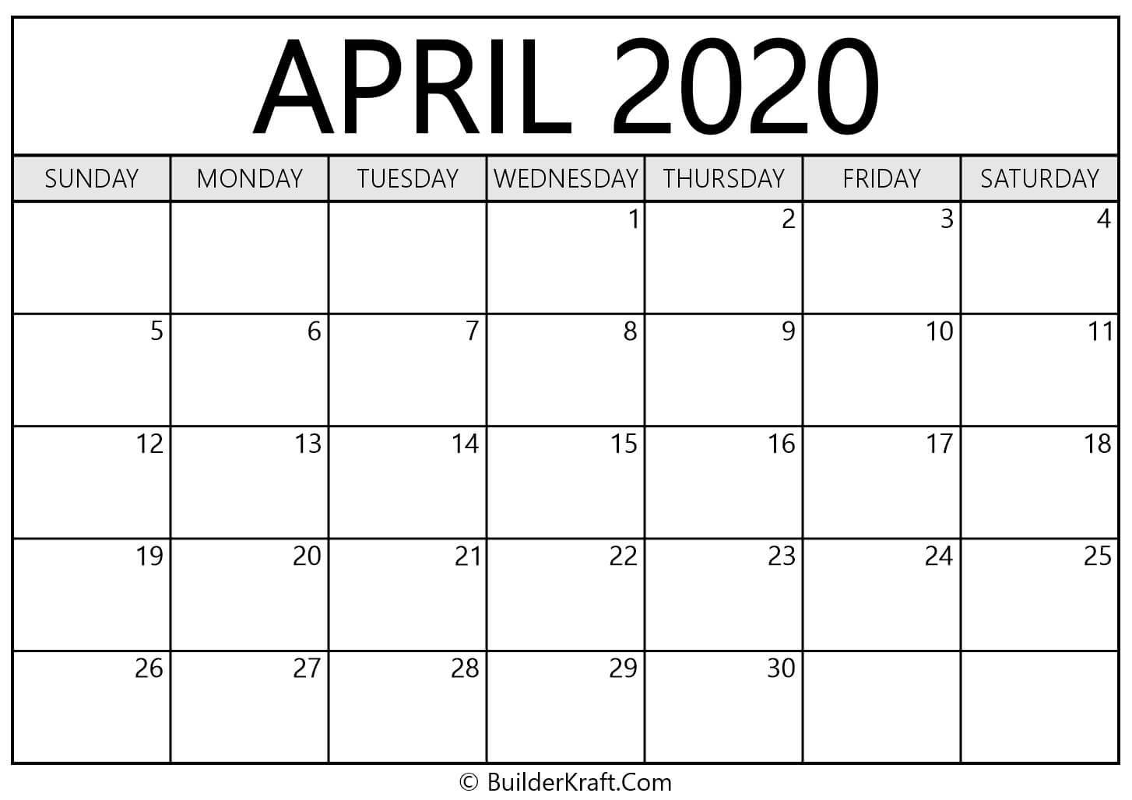
You may wish to use the Calendar below to mark up important dates

