Mollusca Name:
Block:

- List the main characteristics of Mollusca. What are the main body parts of any mollusk.

- Describe each “organ system” (break into gastropoda, bivalva, cephalopoda when needed.

Respiratory

Feeding

Circulatory

Nervous

Reproductive

Movement

Excretory

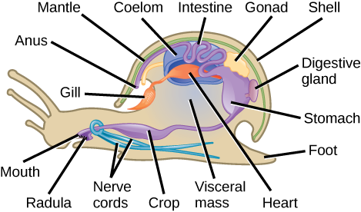
Label the diagram below.

