**Platyhelminthes Overview Name:**

**Block:**

1. List the main characteristics of Platyhelminthes
2. What are the evolutionary advances in flatworms.
3. Describe each organ system

|  |  |
| --- | --- |
| Respiratory |  |
| Digestive |  |
| Circulatory |  |
| Nervous & Movement |  |
| Reproductive  (categorize) |  |

1. What is the advantage of a flattened body?
2. What are the groups of flatworms? Describe each

|  |  |  |
| --- | --- | --- |
|  |  |  |
|  |  |  |

1. 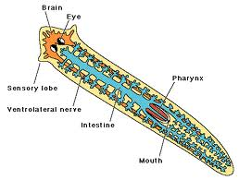Label the diagrams below.