Prokaryotic Cells Vs. Eukaryotic Cells Name: . Block: .

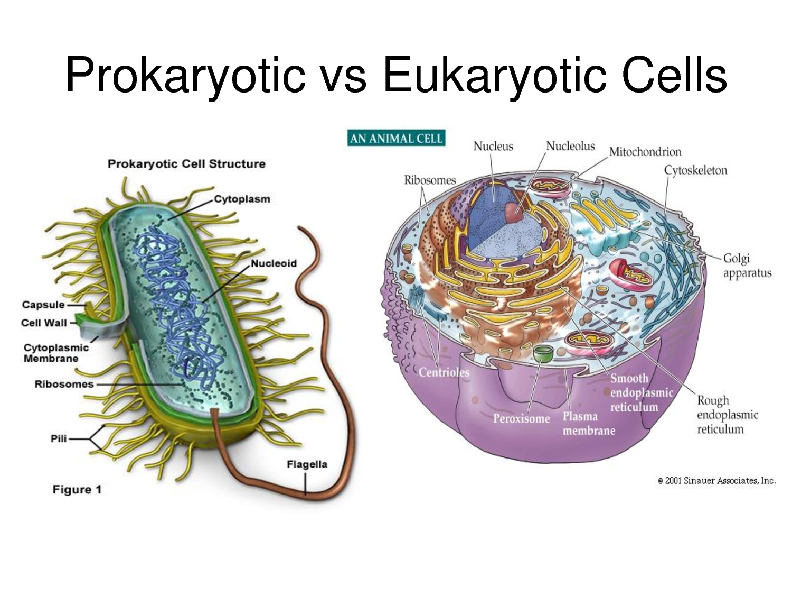
Using the following link compare and contrast a Prokaryotic Cell and a Eukaryotic Cell.

http://www.diffen.com/difference/Eukaryotic_Cell_vs_Prokaryotic_Cell

 | Prokaryotic Cell | Eukaryotic Cell
Nucleus

Membrane- bound organells
Uni/multicellular

Examples

Mitochondria

Ribosomes

Vesicles

Cell wall

Size

Vacuoles

Using the table above, make a Ven Diagram on the back to show the similarities and differences between the 2 types of cells.

