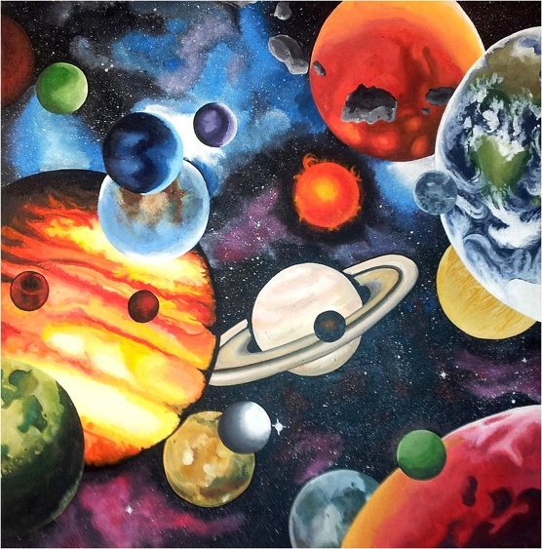
Starry Skies

Now that you have learned how to find reliable websites and
articles (sources); AND you know how to learn and use
Scientific language, you are ready to research reliable
sources about a particular celestial body or scientific
discovery in space.

You are to create a mini essay approximately 1-2pages
double spaced. In your essay you are to use at least 2 reliable
resources that you used to help you learn about the celestial
body or scientific discovery. You can have up to 2 images in your
essay should you wish to have imagery to communicate, but your images should not
take up more than a quarter of your page combined. You are to practice your in-text citation method and you must create an APA styled bibliography/reference page.

Your mini-essay can be about galaxies, stars, planets, our solar system, planets in our solar system, moons, asteroids, comets, telescopes, history of space science, space technologies, important people/animals in the advancement of spaces and more…..

This is a formative task designed to give you feedback on
- Criterion D,
  - strand iii (using scientific language) and
  - strand iv (document the work of others and sources of information used.)

Achievement level | Level descriptor
0 | The student does not reach a standard identified by any of the descriptors below
1-2 | iii. apply scientific language to communicate understanding but does so with limited success  iv. document sources, with limited success.
3-4 | iii. sometimes apply scientific language to communicate understanding  iv. sometimes document sources correctly.
5-6 | iii. usually apply scientific language to communicate understanding clearly and precisely  iv. usually document sources correctly.
7-8 | iii. consistently apply scientific language to communicate understanding clearly and precisely  iv. document sources completely

