Sustainability Project PART I – RESEARCH
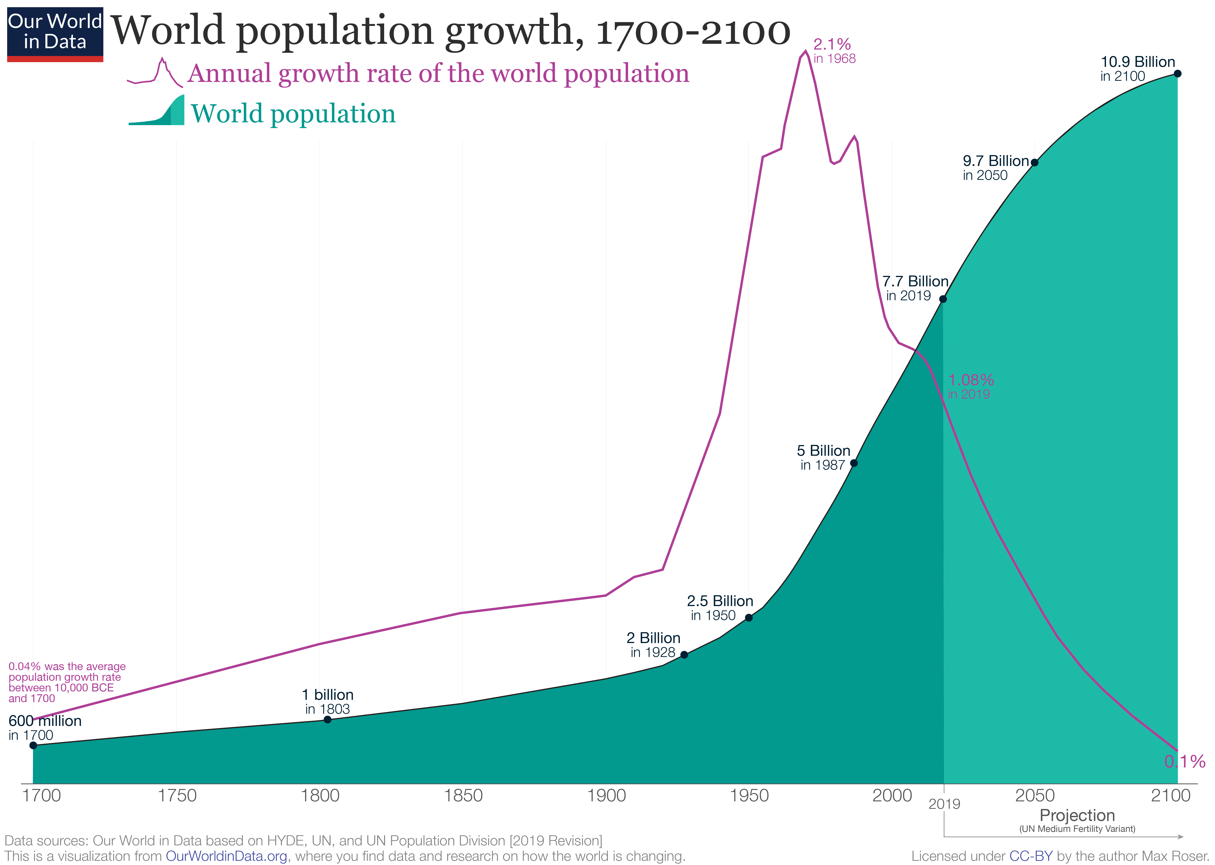
In the recent decades, people have become more conscious of the importance of sustainability. As human population pushes towards over 7billion, we have become the most successful species that has EVER lived on this plant and probably will ever live on the planet. Being social creatures, we have created systems to run cities, provinces/states, countries and our world. Those systems have risen from time immemorial and many “modern” systems are from the time of the industrial revolution.

As technology and intelligence has advanced over the years, those systems have evolved very little. We are living in a “finite” earth, where resources are limited and will eventually run out. However we live our lives as if our resources are “infinite.” For example we take fossil fuels, turn them into plastics and use those plastics one time and trash or “recycle” them. Those plastics are never turning into fossil fuels again. Eventually, we will run out of fossil fuels and plastic (the end product) is already littering our planet.

This part of you sustainability project focuses on you researching system that we have built that is not circular, but linear. That is to say, it is not sustainable and it will fail our needs eventually.

For this part of the project you are to:
- Pick one system that is a failure or will be a failure (see page 2 for suggestions)
  - Detail where it started and how it is failing us or will fail us in the future in as much detail as possible (2-3 paragraphs worth of knowledge)
- Find out if there is an alternative system already invented or produce an alternative system that you think would work.
- Write/draw out steps that need to be taken for the alternative system to take over a neighbourhood, city, province, country or the world.
- What are the pros and cons of the alternative system.

Note:
“System” is a vague term. Systems can be technological (ex. cars), infrastructural (ex roads), social (ex. shaming people for their behaviour), societal (ex. drinking coffee out of paper cup), and more.
This may be overwhelming to think about but pick something that really GRINDS YOUR GEARS.

You are to produce 2-3 pages of notes double spaced, These notes are needed for the next part of the project. Record and submit your sources with your notes

Examples of systems that are failing us.

- Oil as energy
- Coal as energy
- individual cars as transportation     
- suburban houses that take up so much space
- houses that are not energy efficient
- heating of houses
- single use plastics and other products
- consumption of crops that are not farmed sustainably
- consumption of meat that is not raised sustainably
- sewage system
- cosmetic industry
- medication industry
- logging industry
- political systems that focus on economics
- political systems that don’t have sustainability as a priority
- economic system itself
- transportation infrastructure
- systems that harvest food from wild populations
- mining industry
- entertainment industry that doesn’t have sustainability in mind

