The Earth and Weather Name:
Block:

You have now learned about how the earth’s geologic system and climate system work. It is important to bring your learning together in the following assignment.

Use the following diagram of the earth to draw:
- The sun’s rays at latitude 0 (equator) and above 30N
- Draw the circulation of air in 6 convection cells on the right as dictated by the temperature (use videos on website and notes)
- With a big arrow show the rotation of the earth

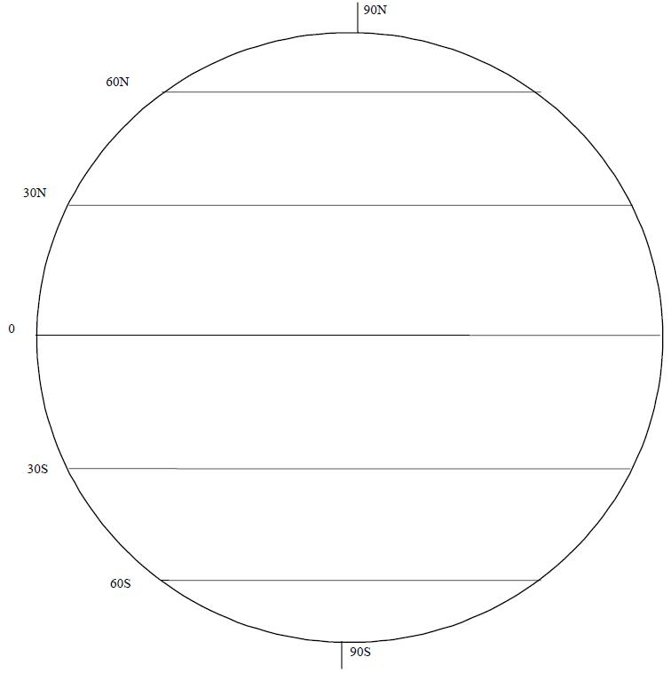

What drives the circulation of these convection cells on earth?

Describe and explain what is happening in the following pictures in terms of topography and weather.
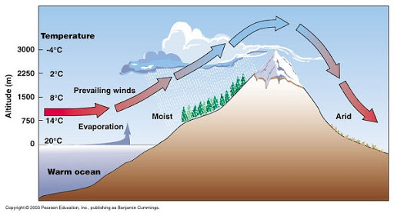

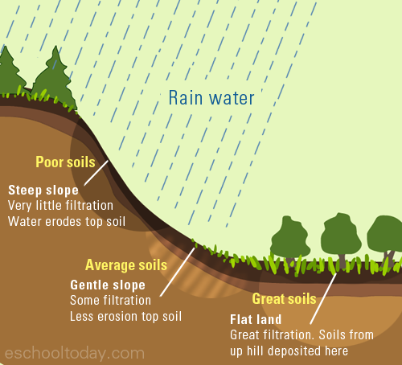

How does topography affect weather and weather affect topography?

