Two-Eyed Seeing Name:

https://www.youtube.com/watch?v=bA9EwcFbVfg

- Why is language so important in the development of culture and identity? Use examples to explain your answer.
________________________________________________________________________________________________________________________________________________________________________________________________________________________________________________________________________________________________________________________________________________________________________________________________________________________________________________________________________________________________________________________________________________________________________________________________________________________________________________________________________________________________________________________________________________________________________________________________________________________

- What does the phrase “lost in translation” mean when it comes to First Peoples languages translated to English?
____________________________________________________________________________________________________________________________________________________________________________________________________________________________________________________________________________________________________________________________________________________________________________________________________________
REFLECTION: How do you think that has impacted Canada and British Columbia’s environmental policies? How does this impact consultations with the First Nations when it comes to land use for things such as pipelines?
________________________________________________________________________________________________________________________________________________________________________________________________________________________________________________________________________________________________________________________________________________________________________________________________________________________________________________________________________________________________________________________________________________________________________________________________________________________________________________________________________________________________________________________________________________________________________________________________________________________

- What is two-eyed seeing? What is an example?
__________________________________________________________________________________________________________________________________________________________________________________________________________________________________________________________________________________________________________________________________________________________________________________________________________________________________________________________________________________________________________________________________________________________________________________________________________________
_________________________________________________________________________________________________________________________________________________________________________________________________________________________________________________________________________________________________________
- Use the images below to describe them using two-eyed seeing.

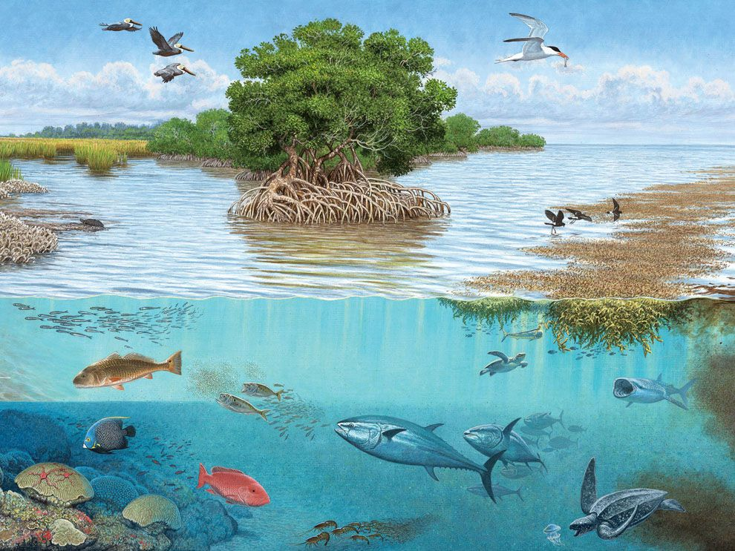
Scientific: Holistic:
Ex. predator-prey .ex. fish provide food
____________________________ for all .
____________________________ ____________________________
_________________________________
_________________________________
_________________________________
_________________________________
_________________________________
__________________________________
__________________________________
__________________________________
______
____________________________

____________________________
____________________________
____________________________
____________________________
____________________________
____________________________
____________________________

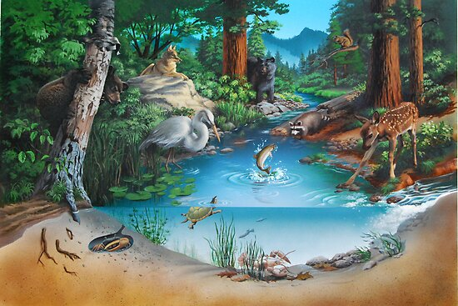

Scientific: Holistic:
____________________________________________
_______________________________________________
_______________________________________________
_______________________________________________
_______________________________________________
_______________________________________________
_______________________________________________
_______________________________________________
_______________________________________________
_______________________________________________

____________________________________________
____________________________________________
____________________________________________
______________________________________________
___________________________________________
_____________________________________________
_______________________________________________

